**VISVESVARAYA TECHNOLOGICAL UNIVERSITY**

**“JnanaSangama”, Belgaum -590014, Karnataka.**



# LAB REPORT on

**Artificial Intelligence (23CS5PCAIN)**

***Submitted by***

**Soham Arora (1BM23CS334)**

***in partial fulfillment for the award of the degree of***

**BACHELOR OF ENGINEERING**

***in***

# COMPUTER SCIENCE AND ENGINEERING



**B.M.S. COLLEGE OF ENGINEERING**

**(Autonomous Institution under VTU)**

# BENGALURU-560019

# Aug 2025 to Dec 2025

**B.M.S. College of Engineering,**

**Bull Temple Road, Bangalore 560019**

(Affiliated To Visvesvaraya Technological University, Belgaum)

## Department of Computer Science and Engineering



**CERTIFICATE**

This is to certify that the Lab work entitled “Artificial Intelligence (23CS5PCAIN)” carried out by **Soham Arora (1BM23CS334),** who is bonafide student of **B.M.S. College of**

**Engineering.** It is in partial fulfillment for the award of **Bachelor of Engineering in Computer Science and Engineering** of the Visvesvaraya Technological University, Belgaum. The Lab report has been approved as it satisfies the academic requirements in respect of an Artificial Intelligence (23CS5PCAIN) work prescribed for the said degree.

|  |  |
| --- | --- |
| Seema Patil  Assistant Professor  Department of CSE, BMSCE | Dr. Kavitha Sooda  Professor & HOD  Department of CSE, BMSCE |

# Index

|  |  |  |  |
| --- | --- | --- | --- |
| **Sl.**  **No.** | **Date** | **Experiment Title** | **Page No.** |
| 1 | 18-6-2025 | Implement Tic –Tac –Toe Game  Implement vacuum cleaner agent | 4 |
| 2 | 1-9-2025 | Implement 8 puzzle problems using Depth First  Search (DFS)  Implement Iterative deepening search algorithm | 15 |
| 3 | 08-09-2025 | Implement A* search algorithm | 27 |
| 4 | 15-09-2025 | Implement Hill Climbing search algorithm to solve N-Queens problem | 34 |
| 5 | 15-09-2025 | Simulated Annealing to Solve 8-Queens problem | 37 |
| 6 | 22-09-2025 | Create a knowledge base using propositional logic and show that the given query entails the knowledge base or not. | 40 |
| 7 | 13-10-2025 | Implement unification in first order logic | 47 |
| 8 | 13-10-2025 | Create a knowledge base consisting of first order logic statements and prove the given query using forward reasoning. | 50 |
| 9 | 27-10-2025 | Create a knowledge base consisting of first order logic statements and prove the given query using Resolution | 54 |
| 10 | 27-10-2025 | Implement Alpha-Beta Pruning. | 60 |

Github Link:https://github.com/sohamArora1605/1BM23CS334AI

**Program 1**

Implement Tic –Tac –Toe Game Implement vacuum cleaner agent

Algorithm:

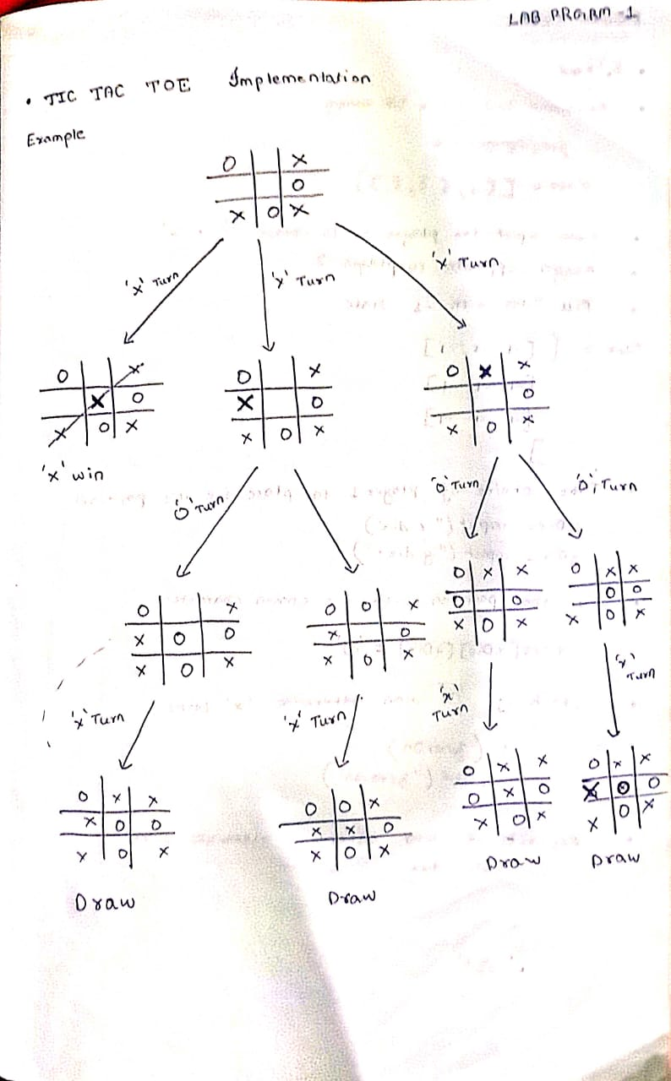

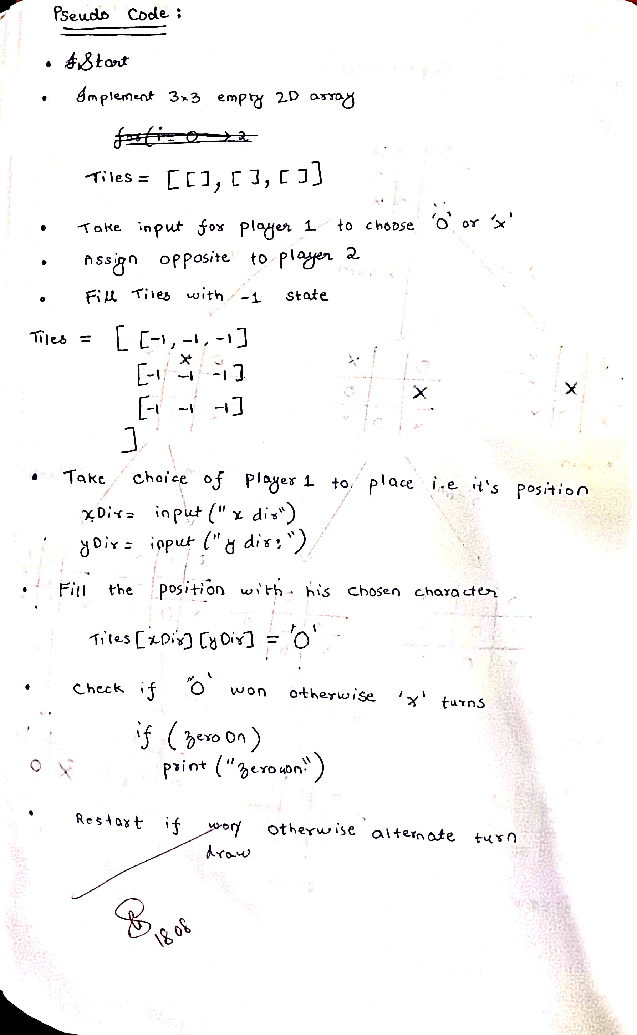

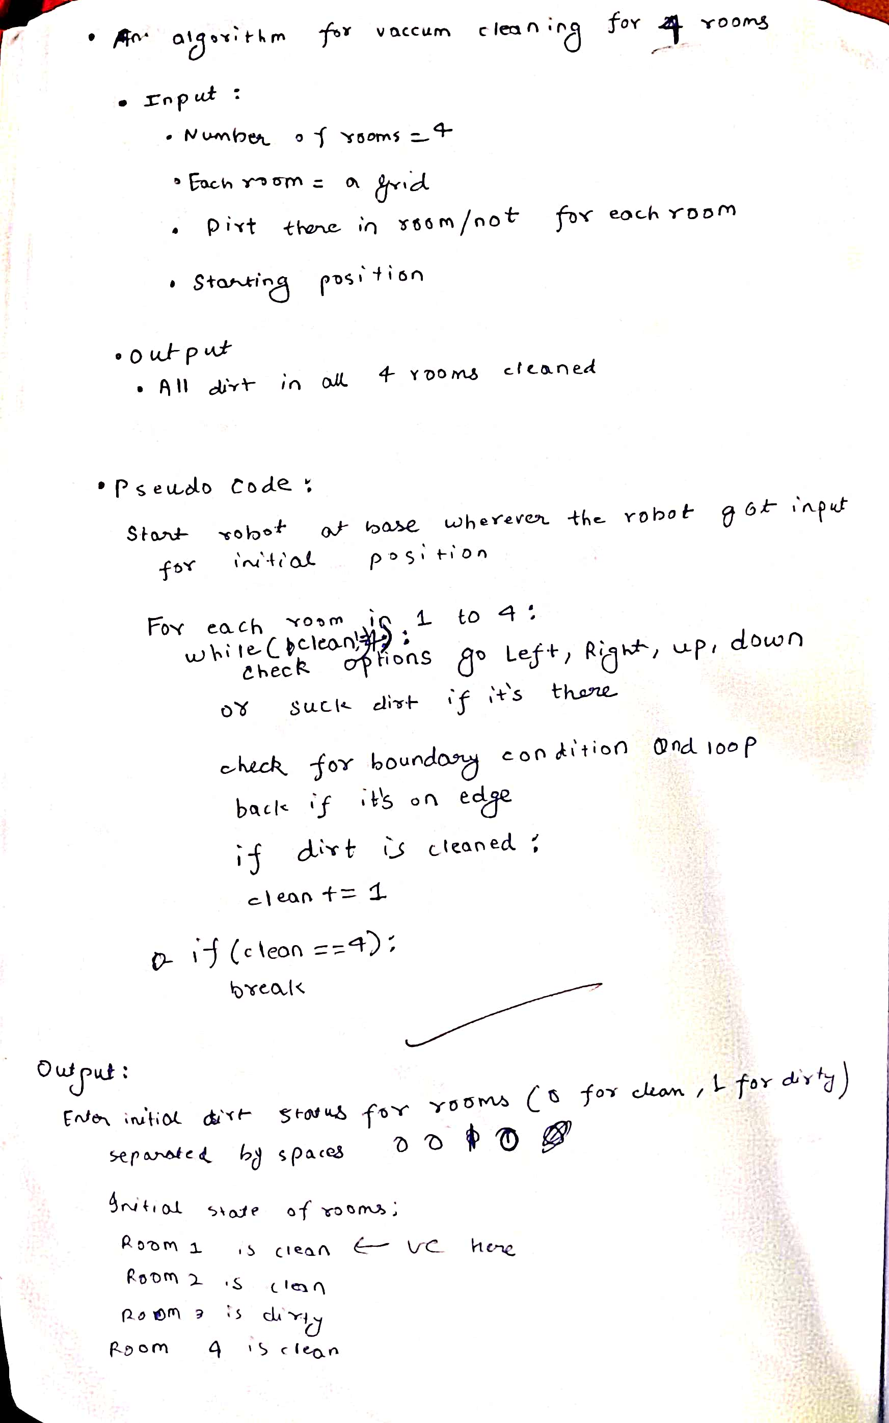

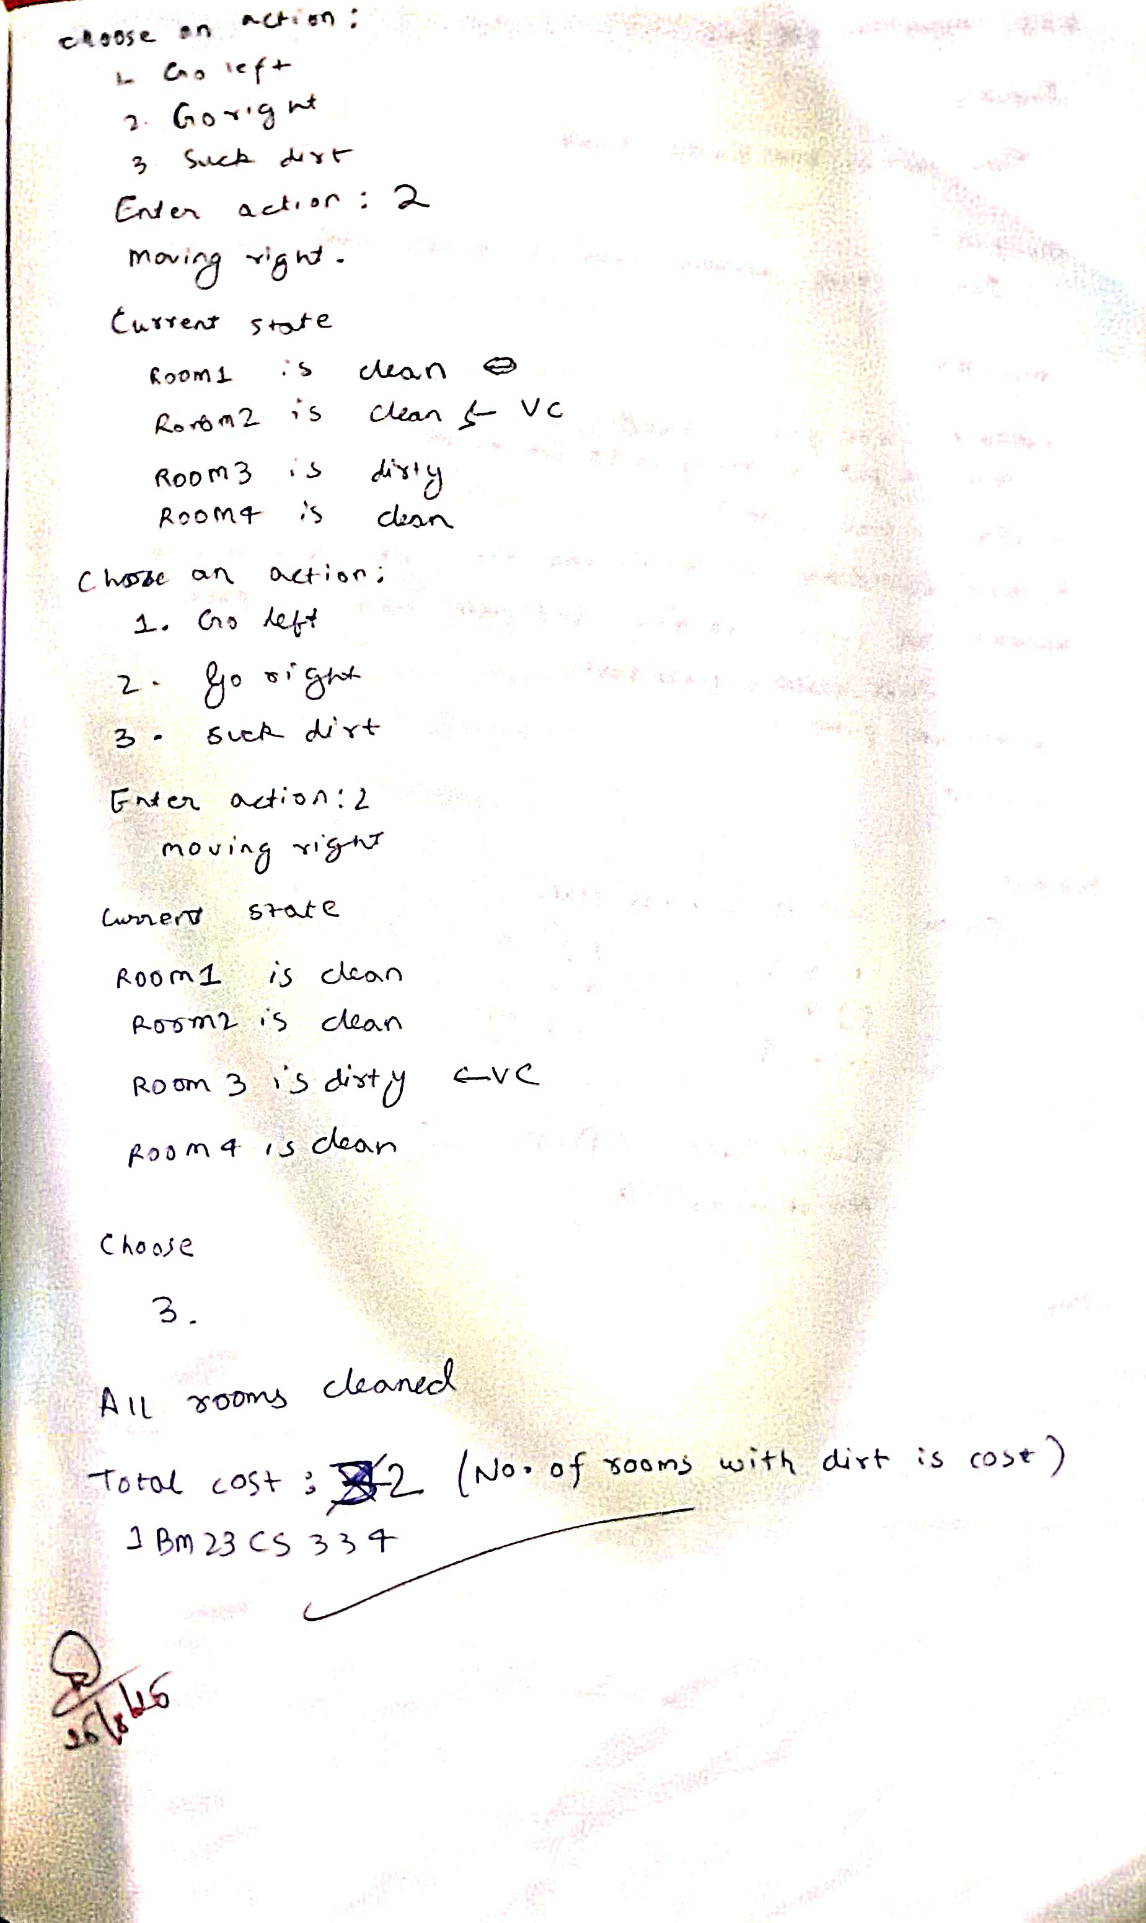

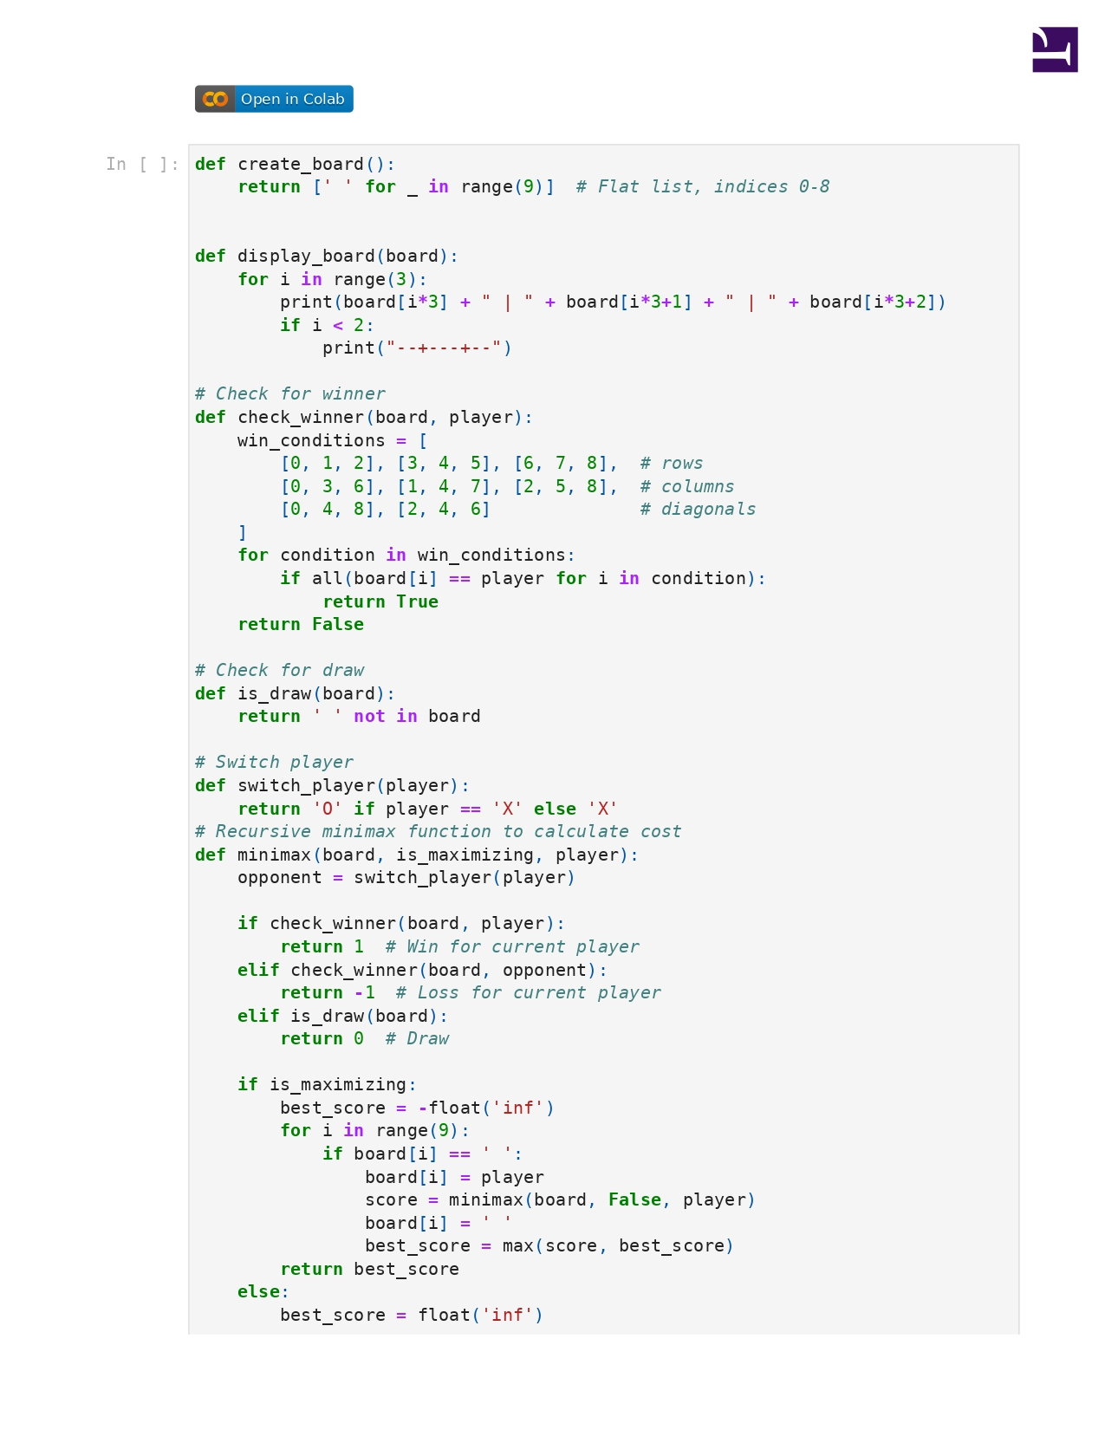

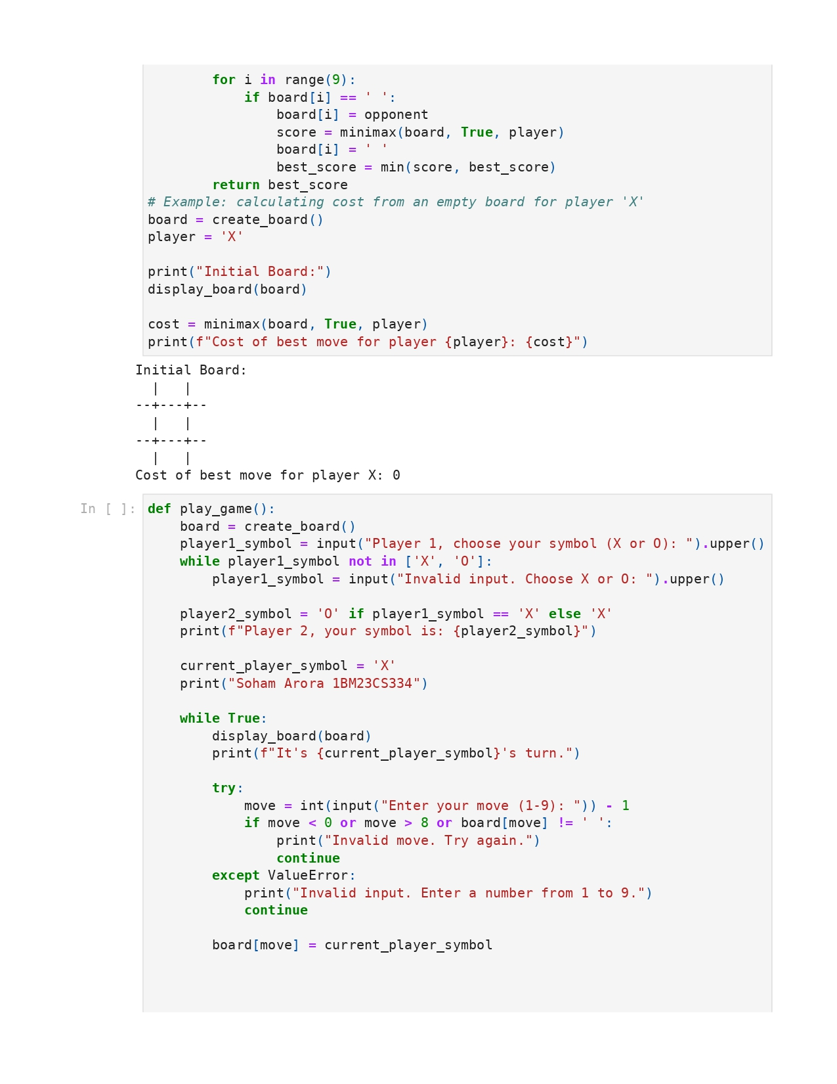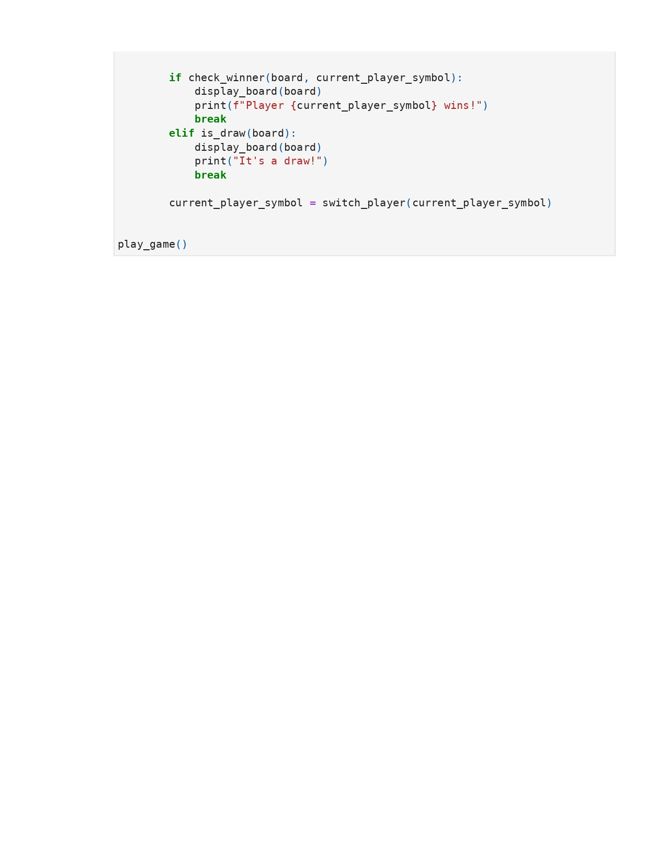

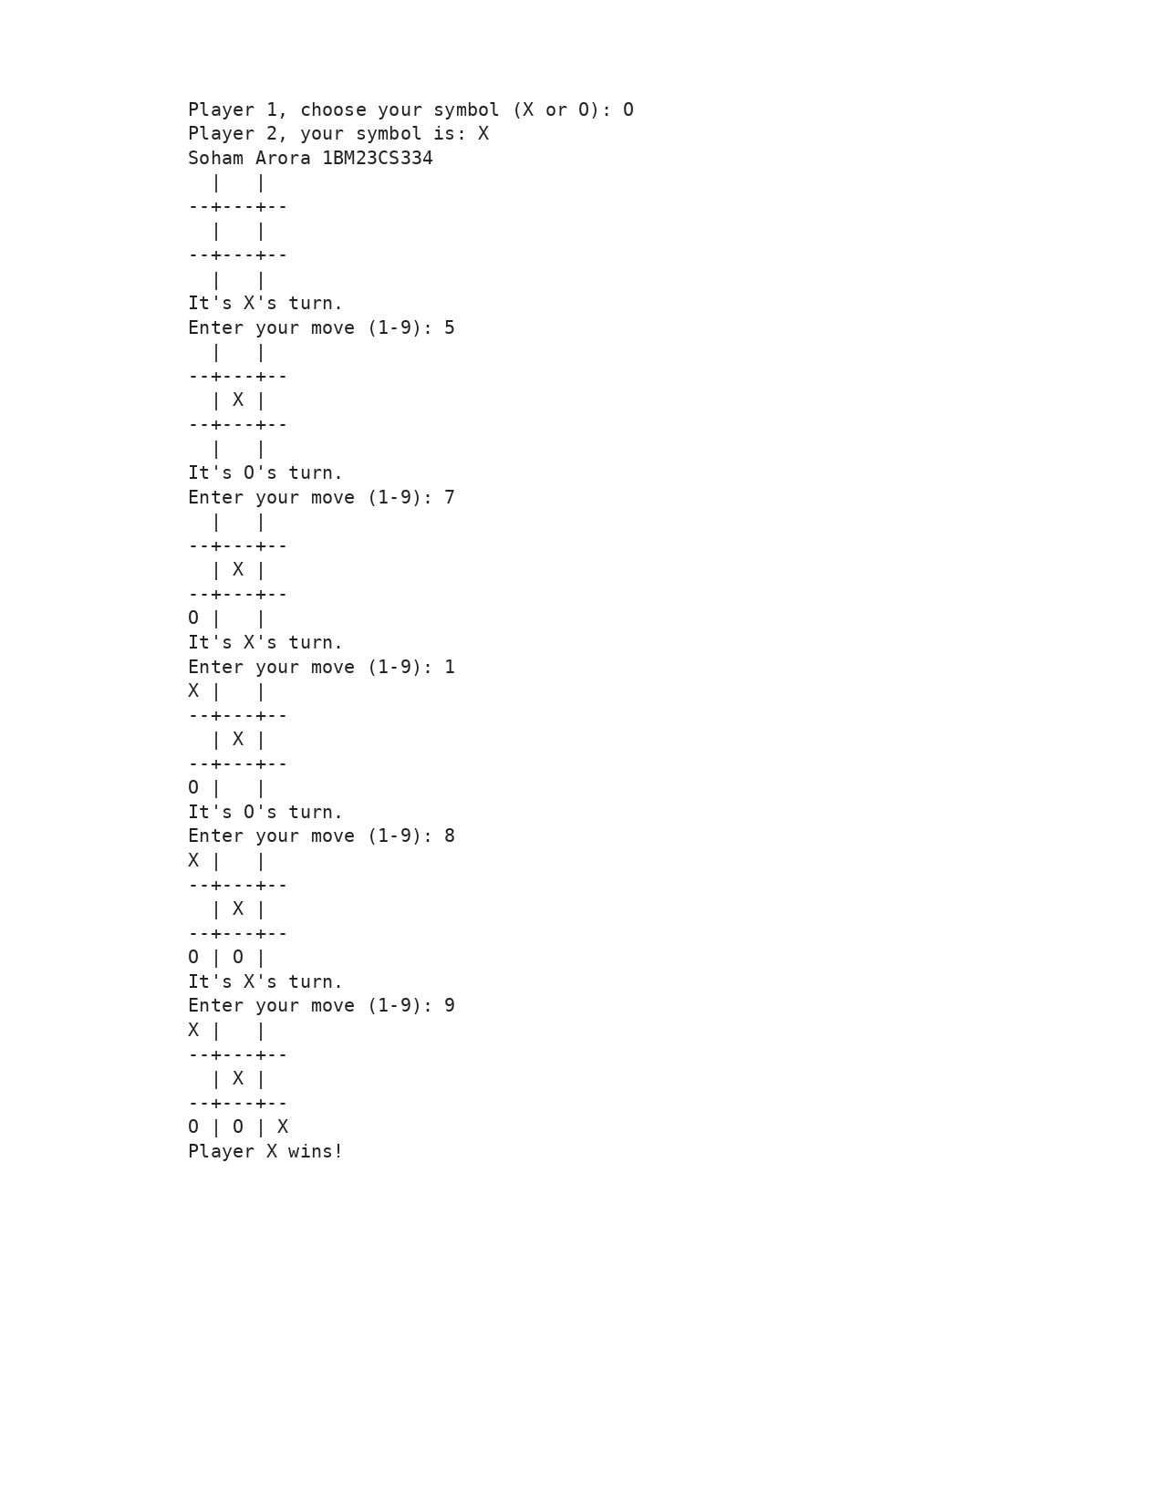

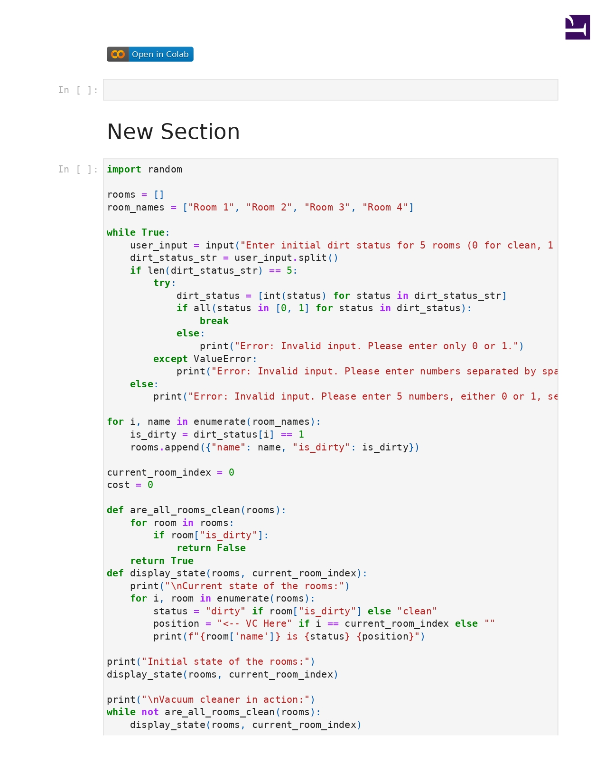

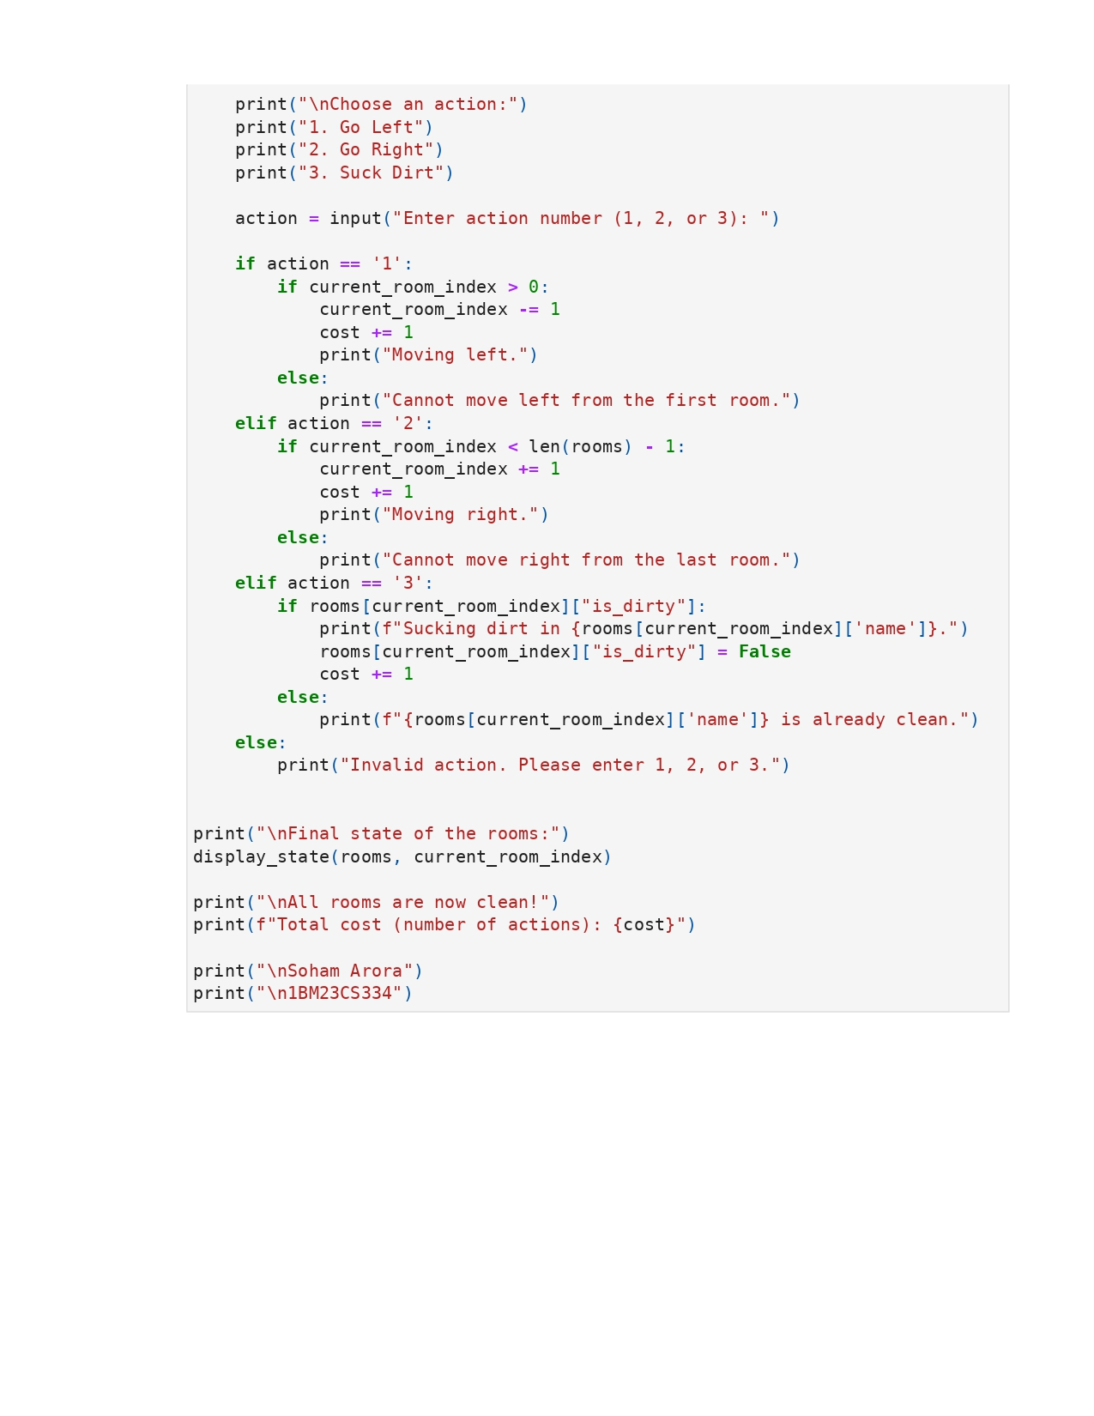

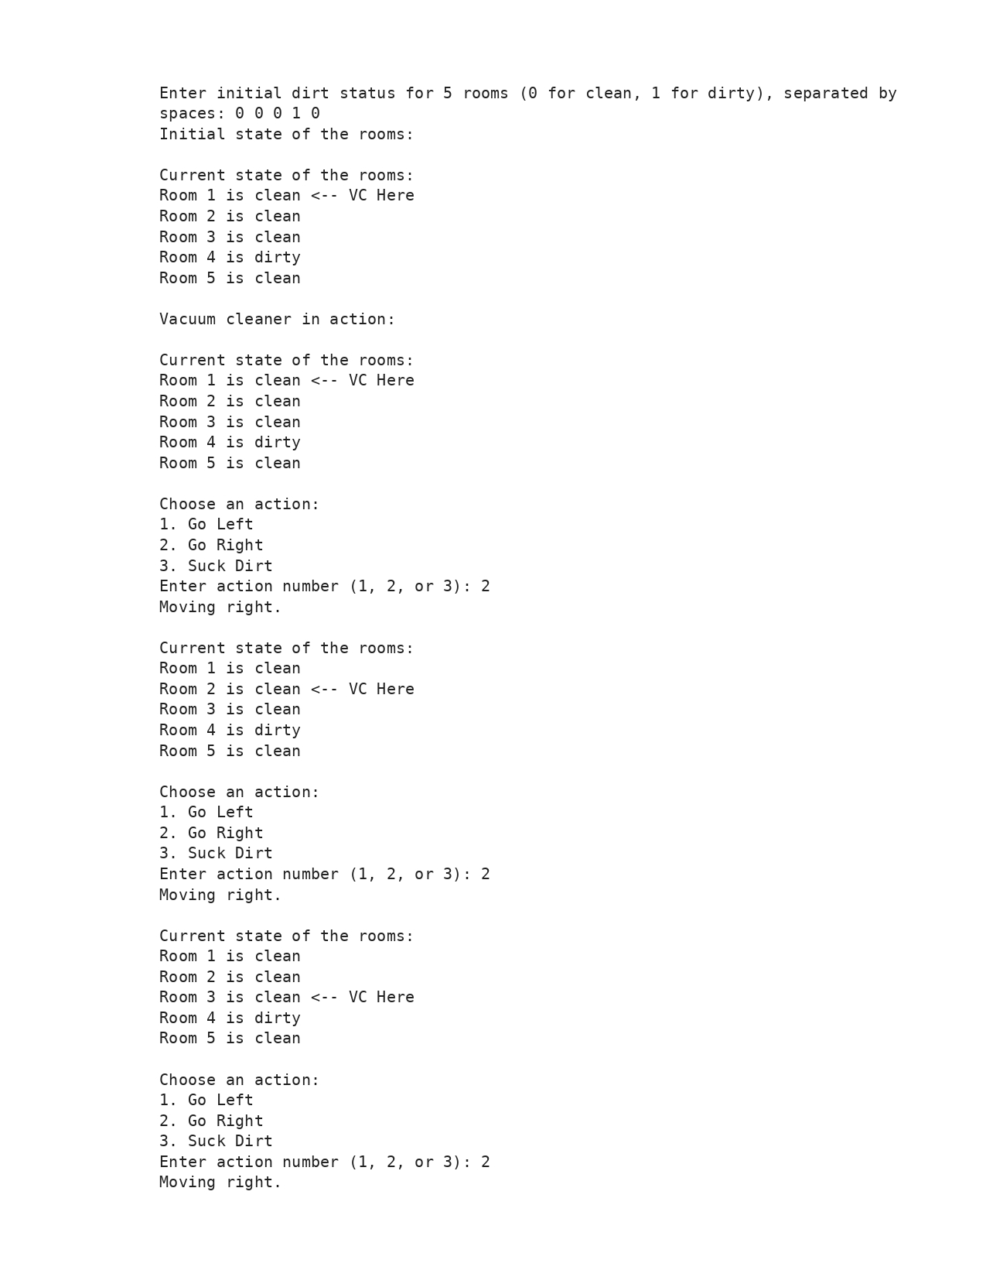

**Program 2**

Implement 8 puzzle problems using Depth First Search (DFS)

Implement Iterative deepening search algorithm

Algorithm:

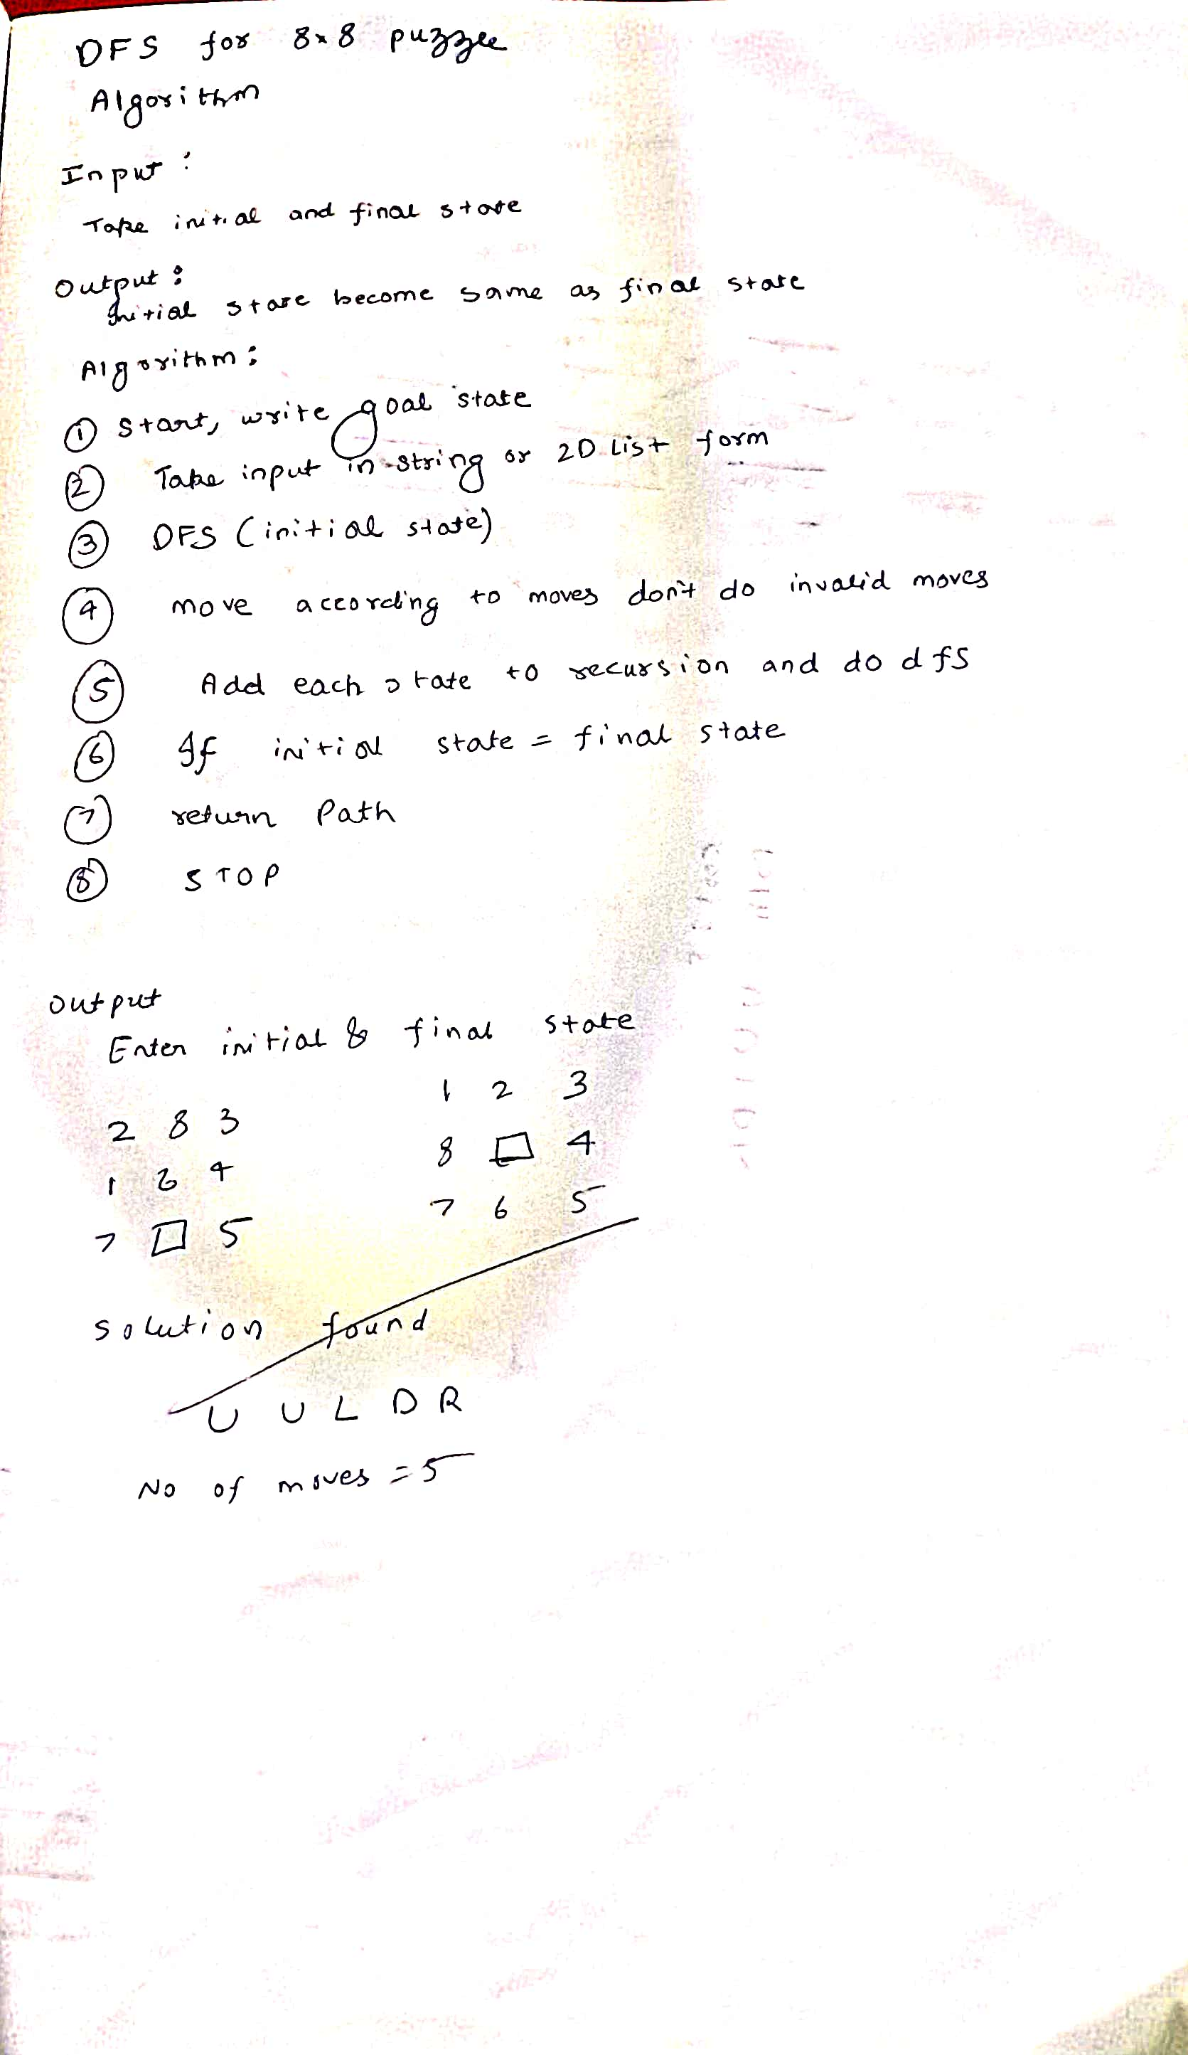

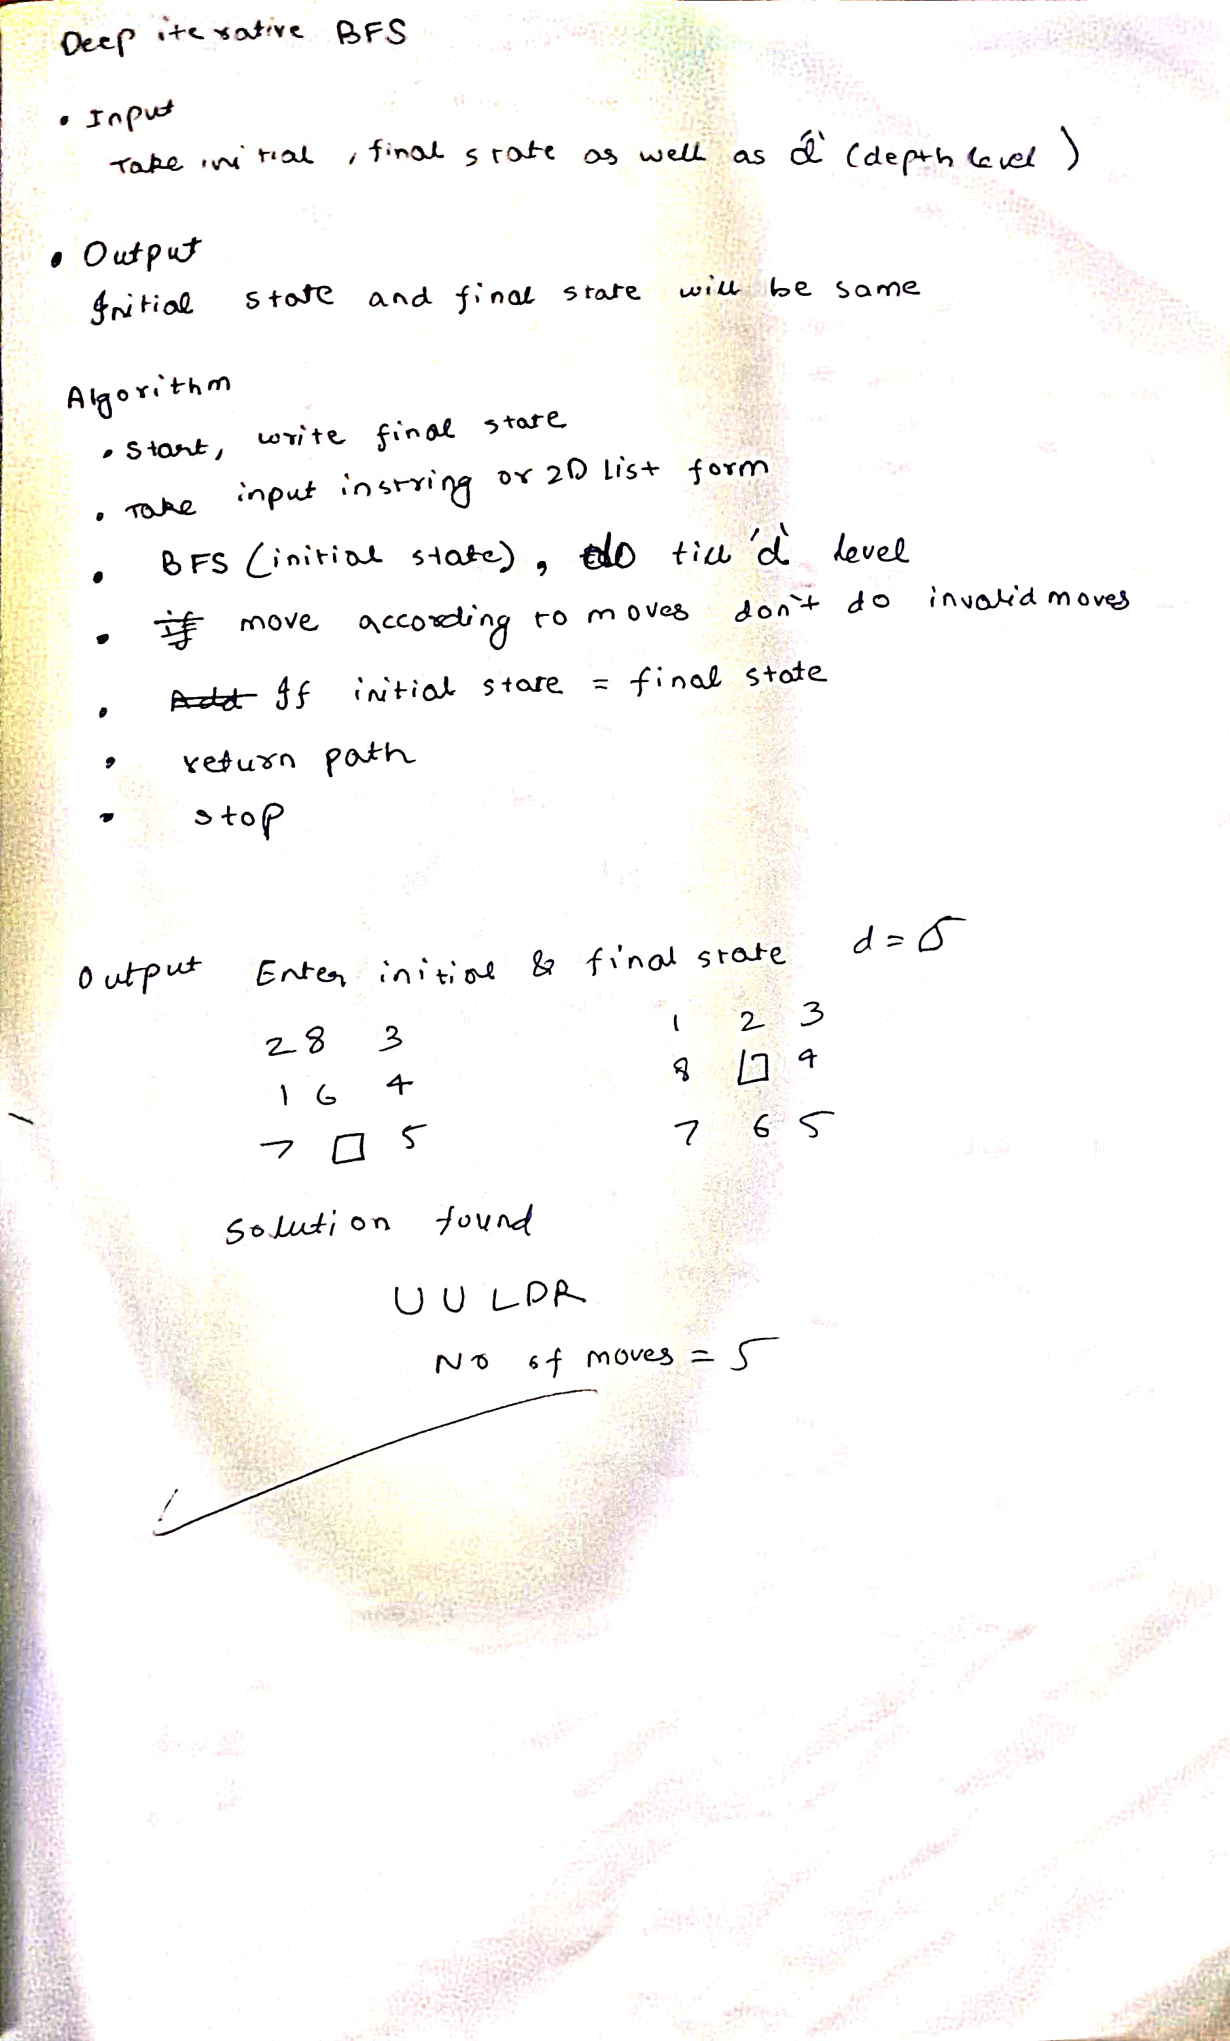

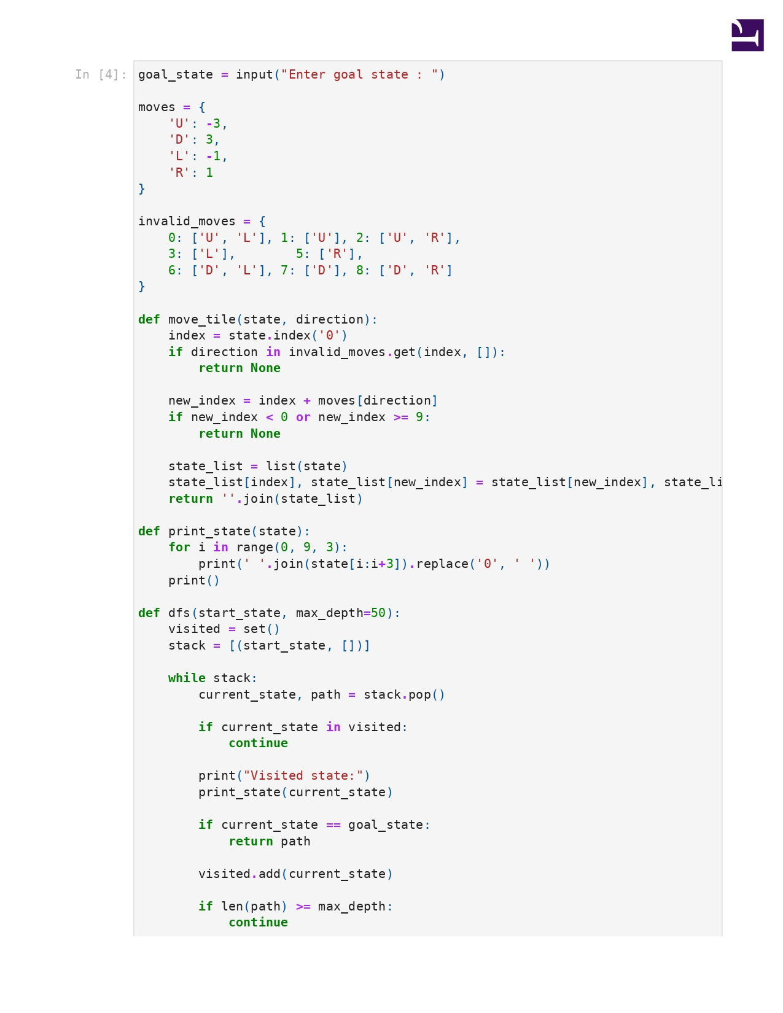

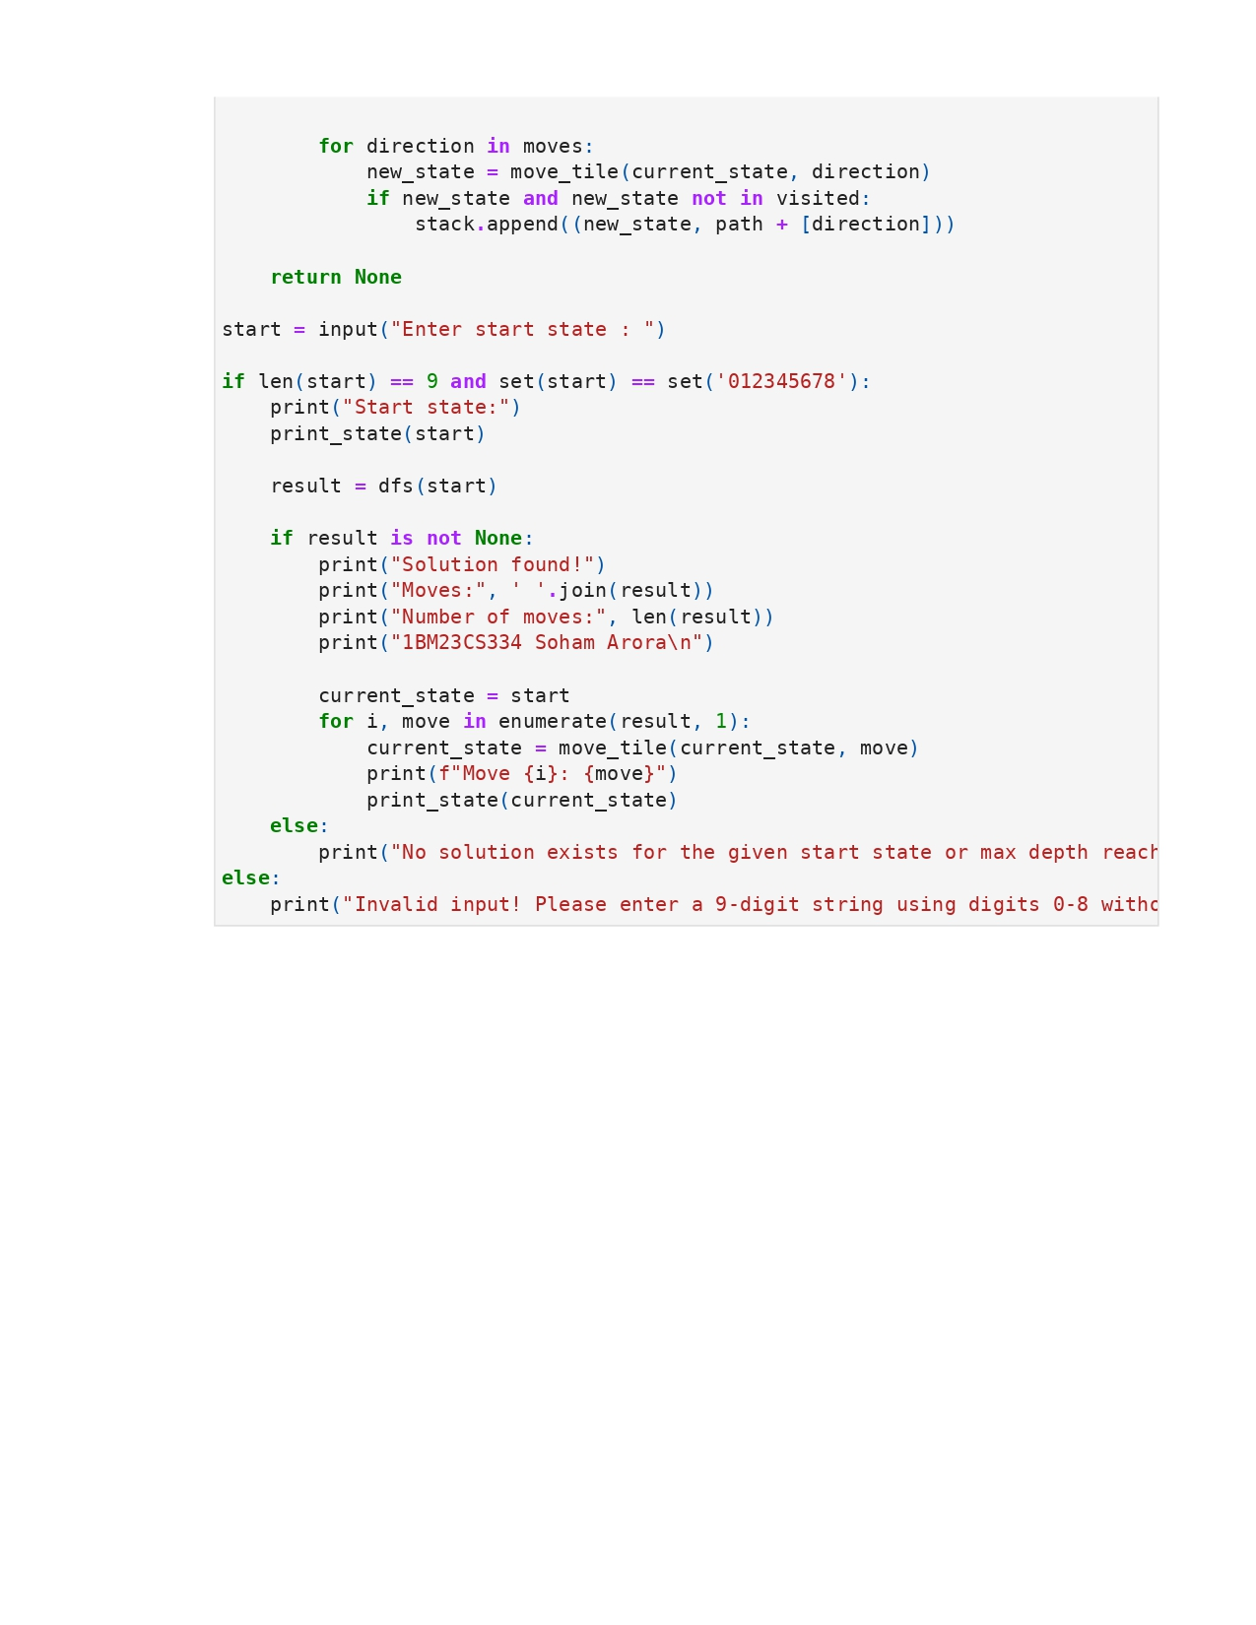

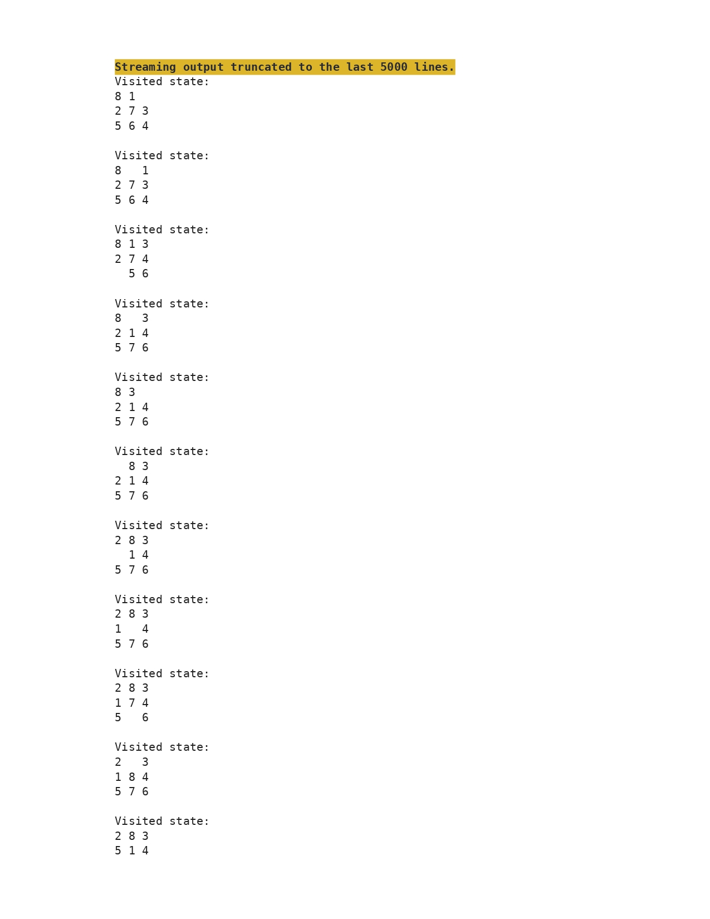

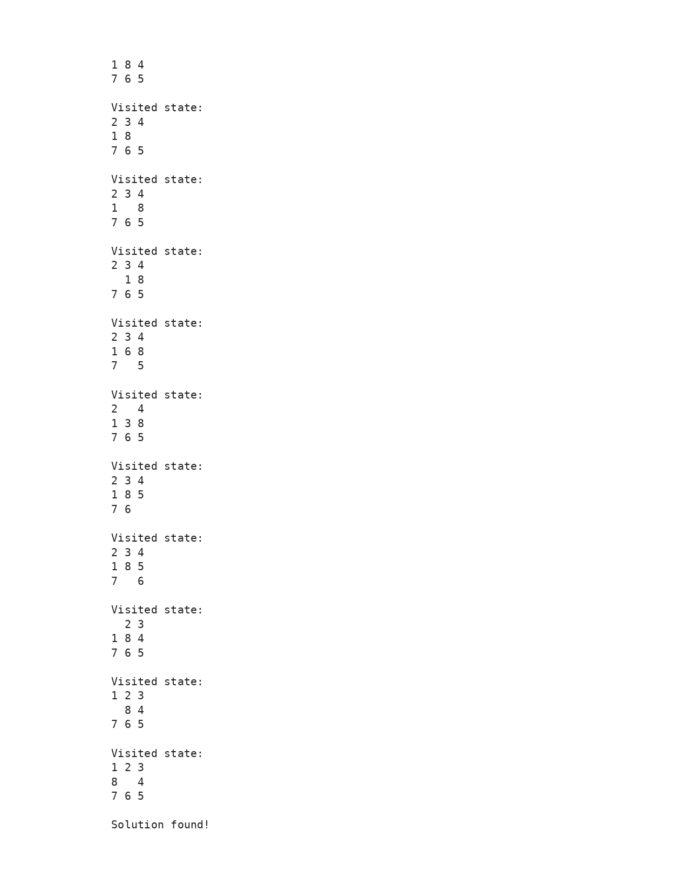

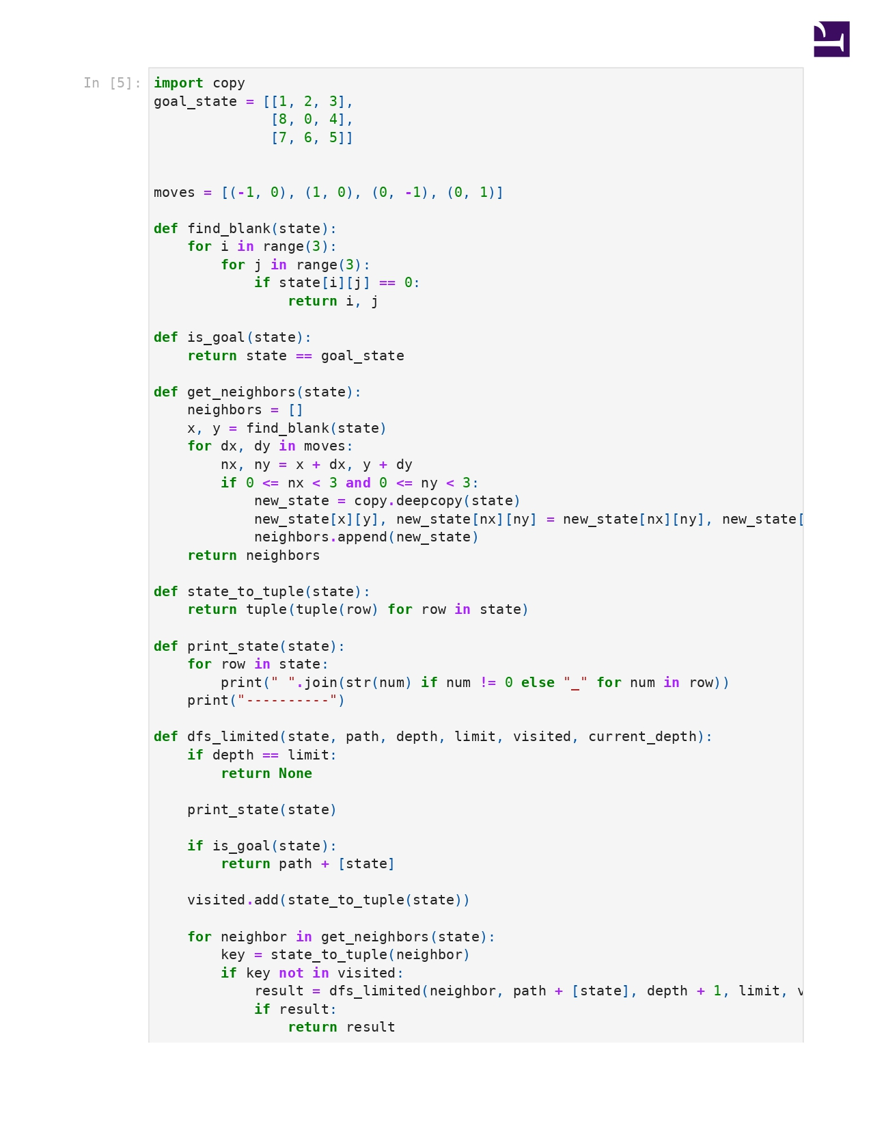

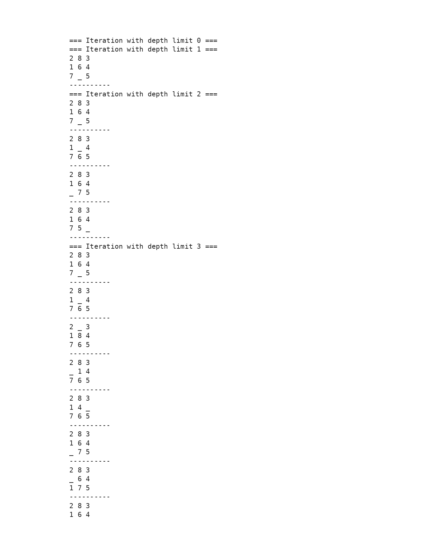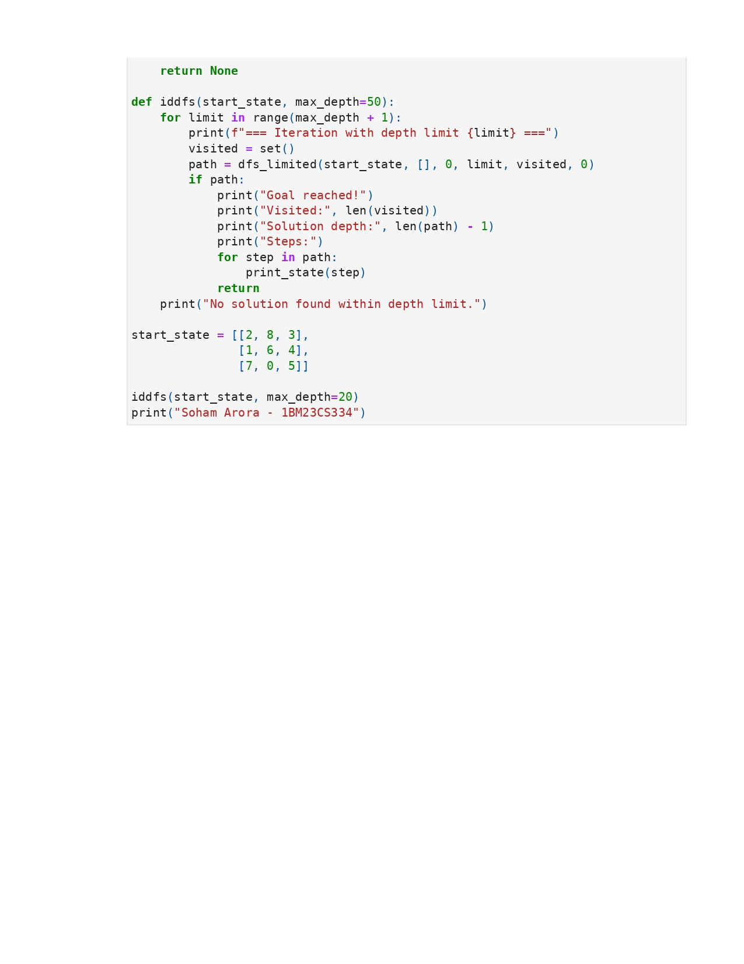

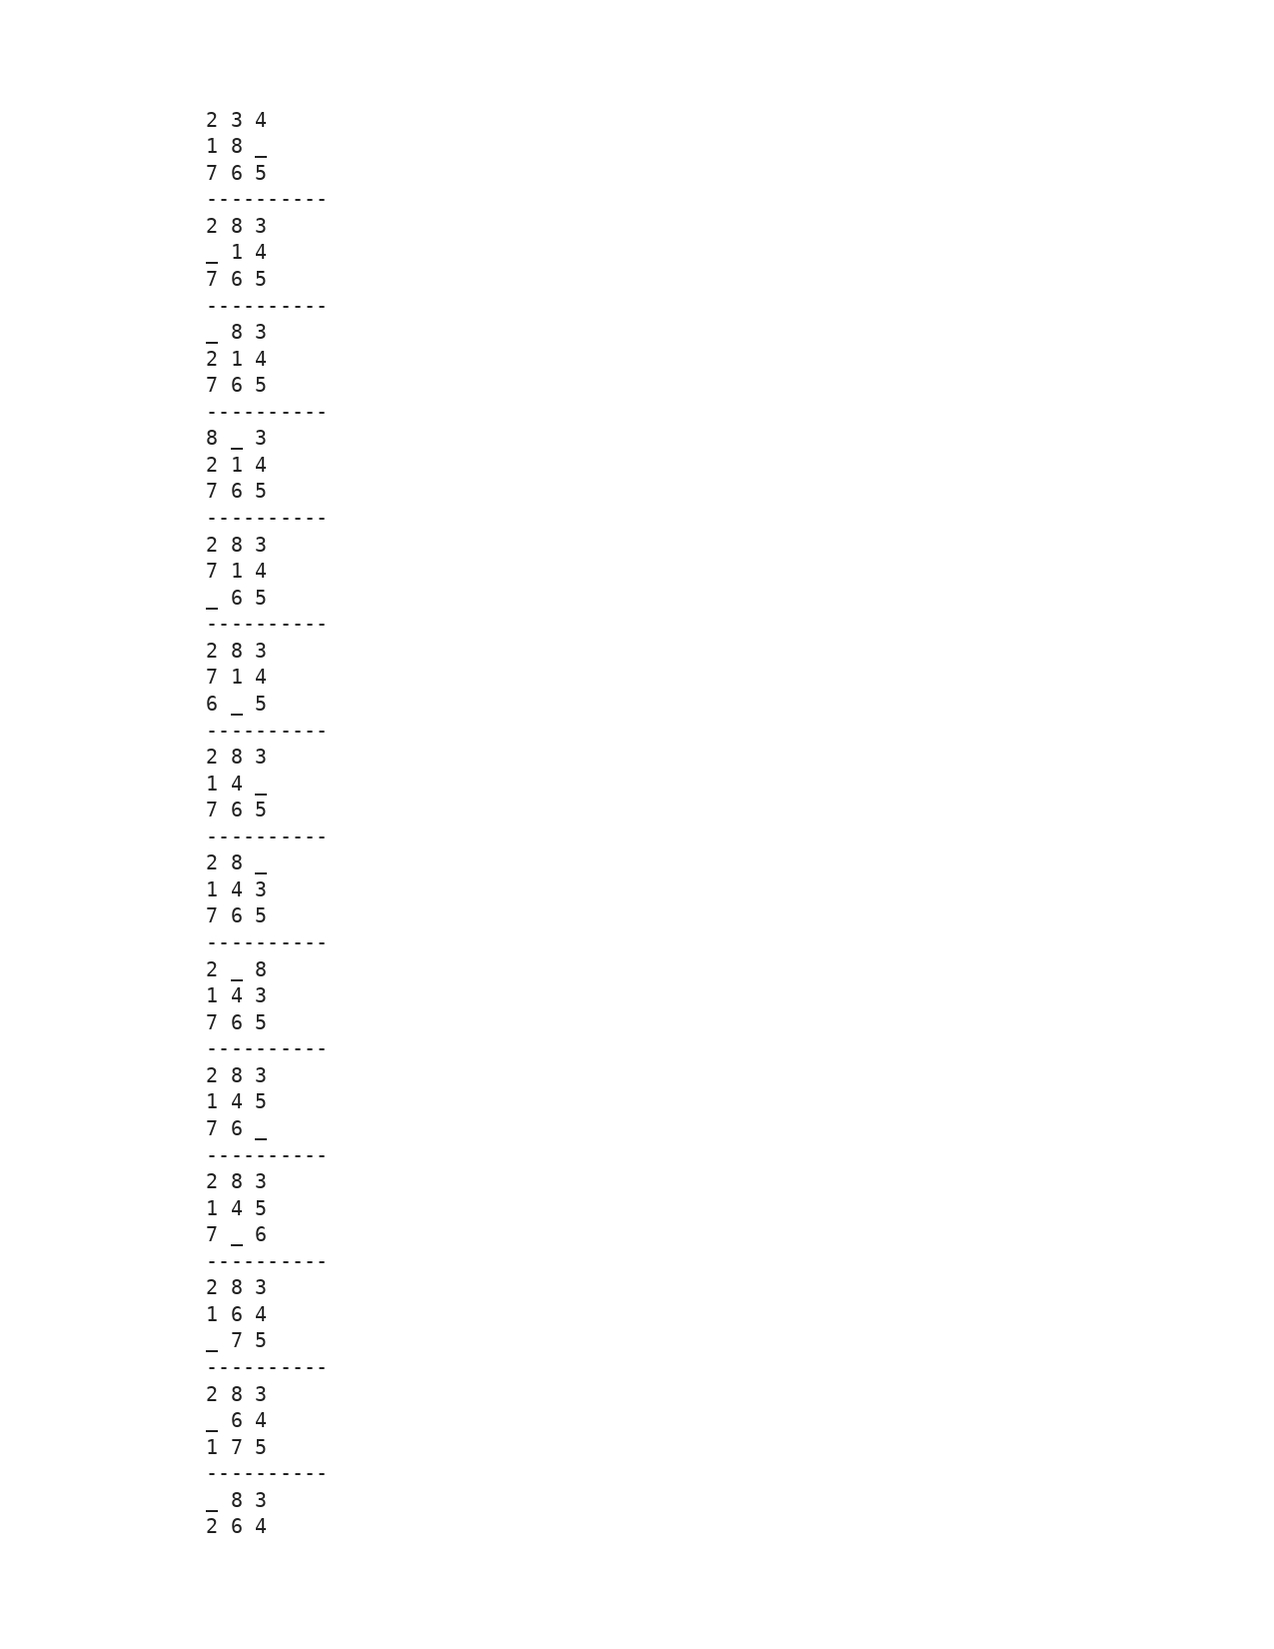

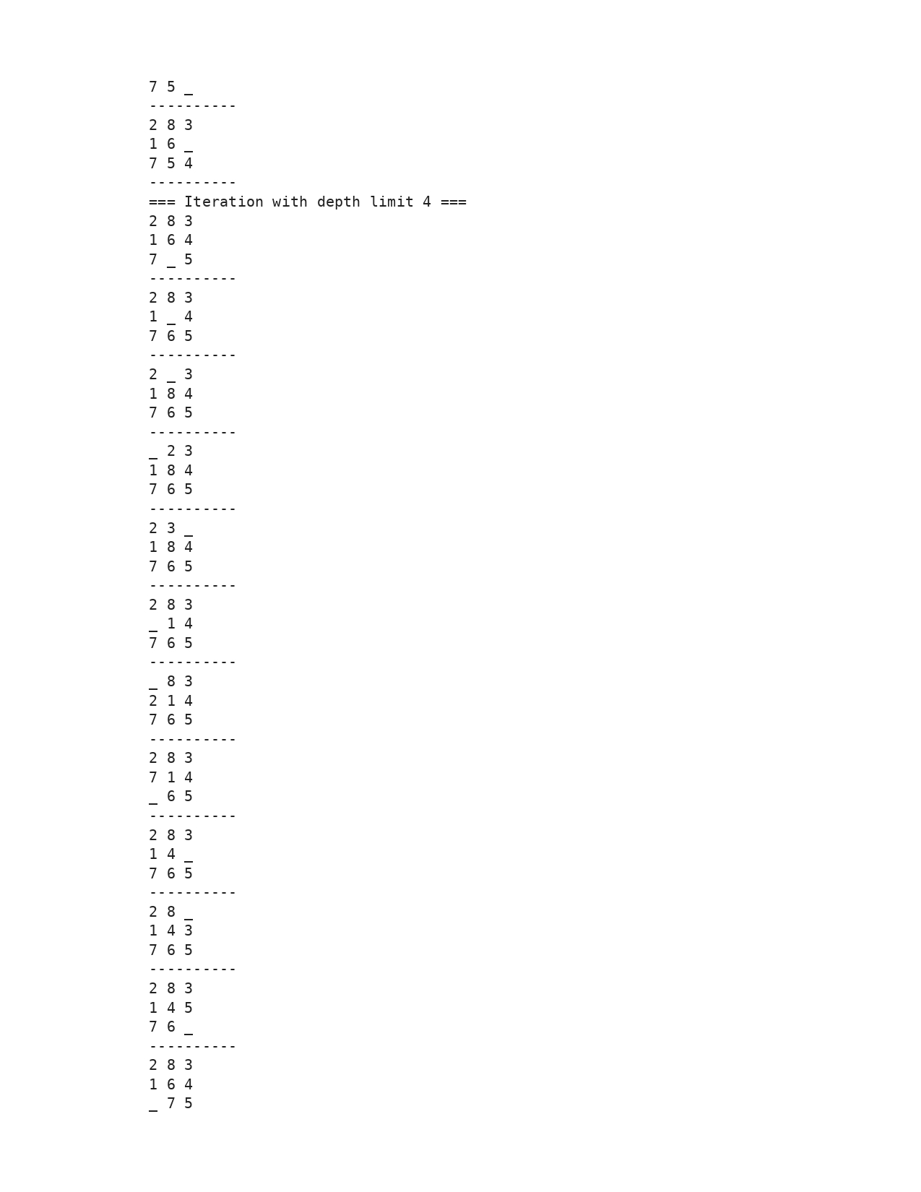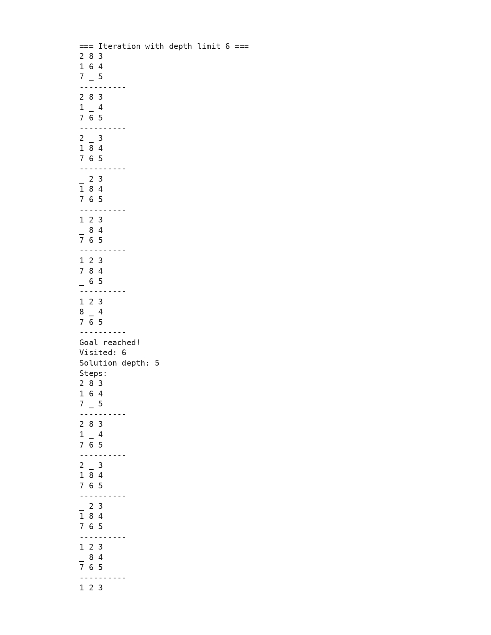

**Program 3**

Implement A* search algorithm

Algorithm:

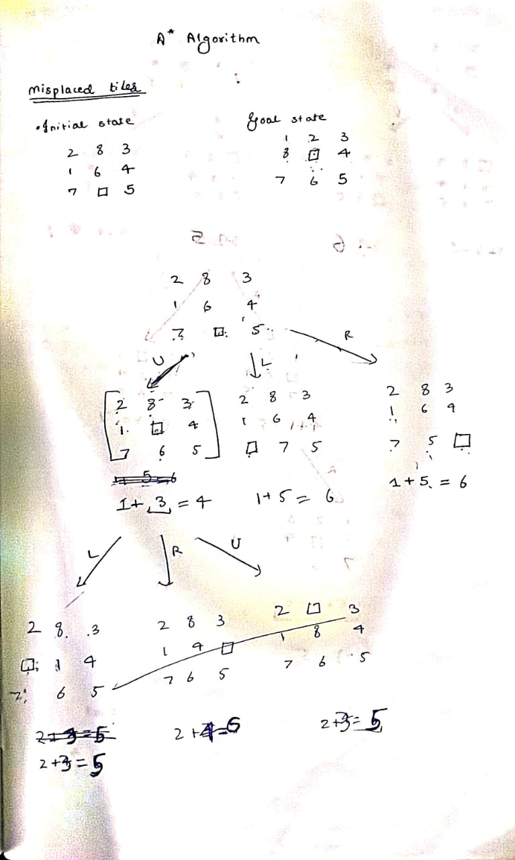

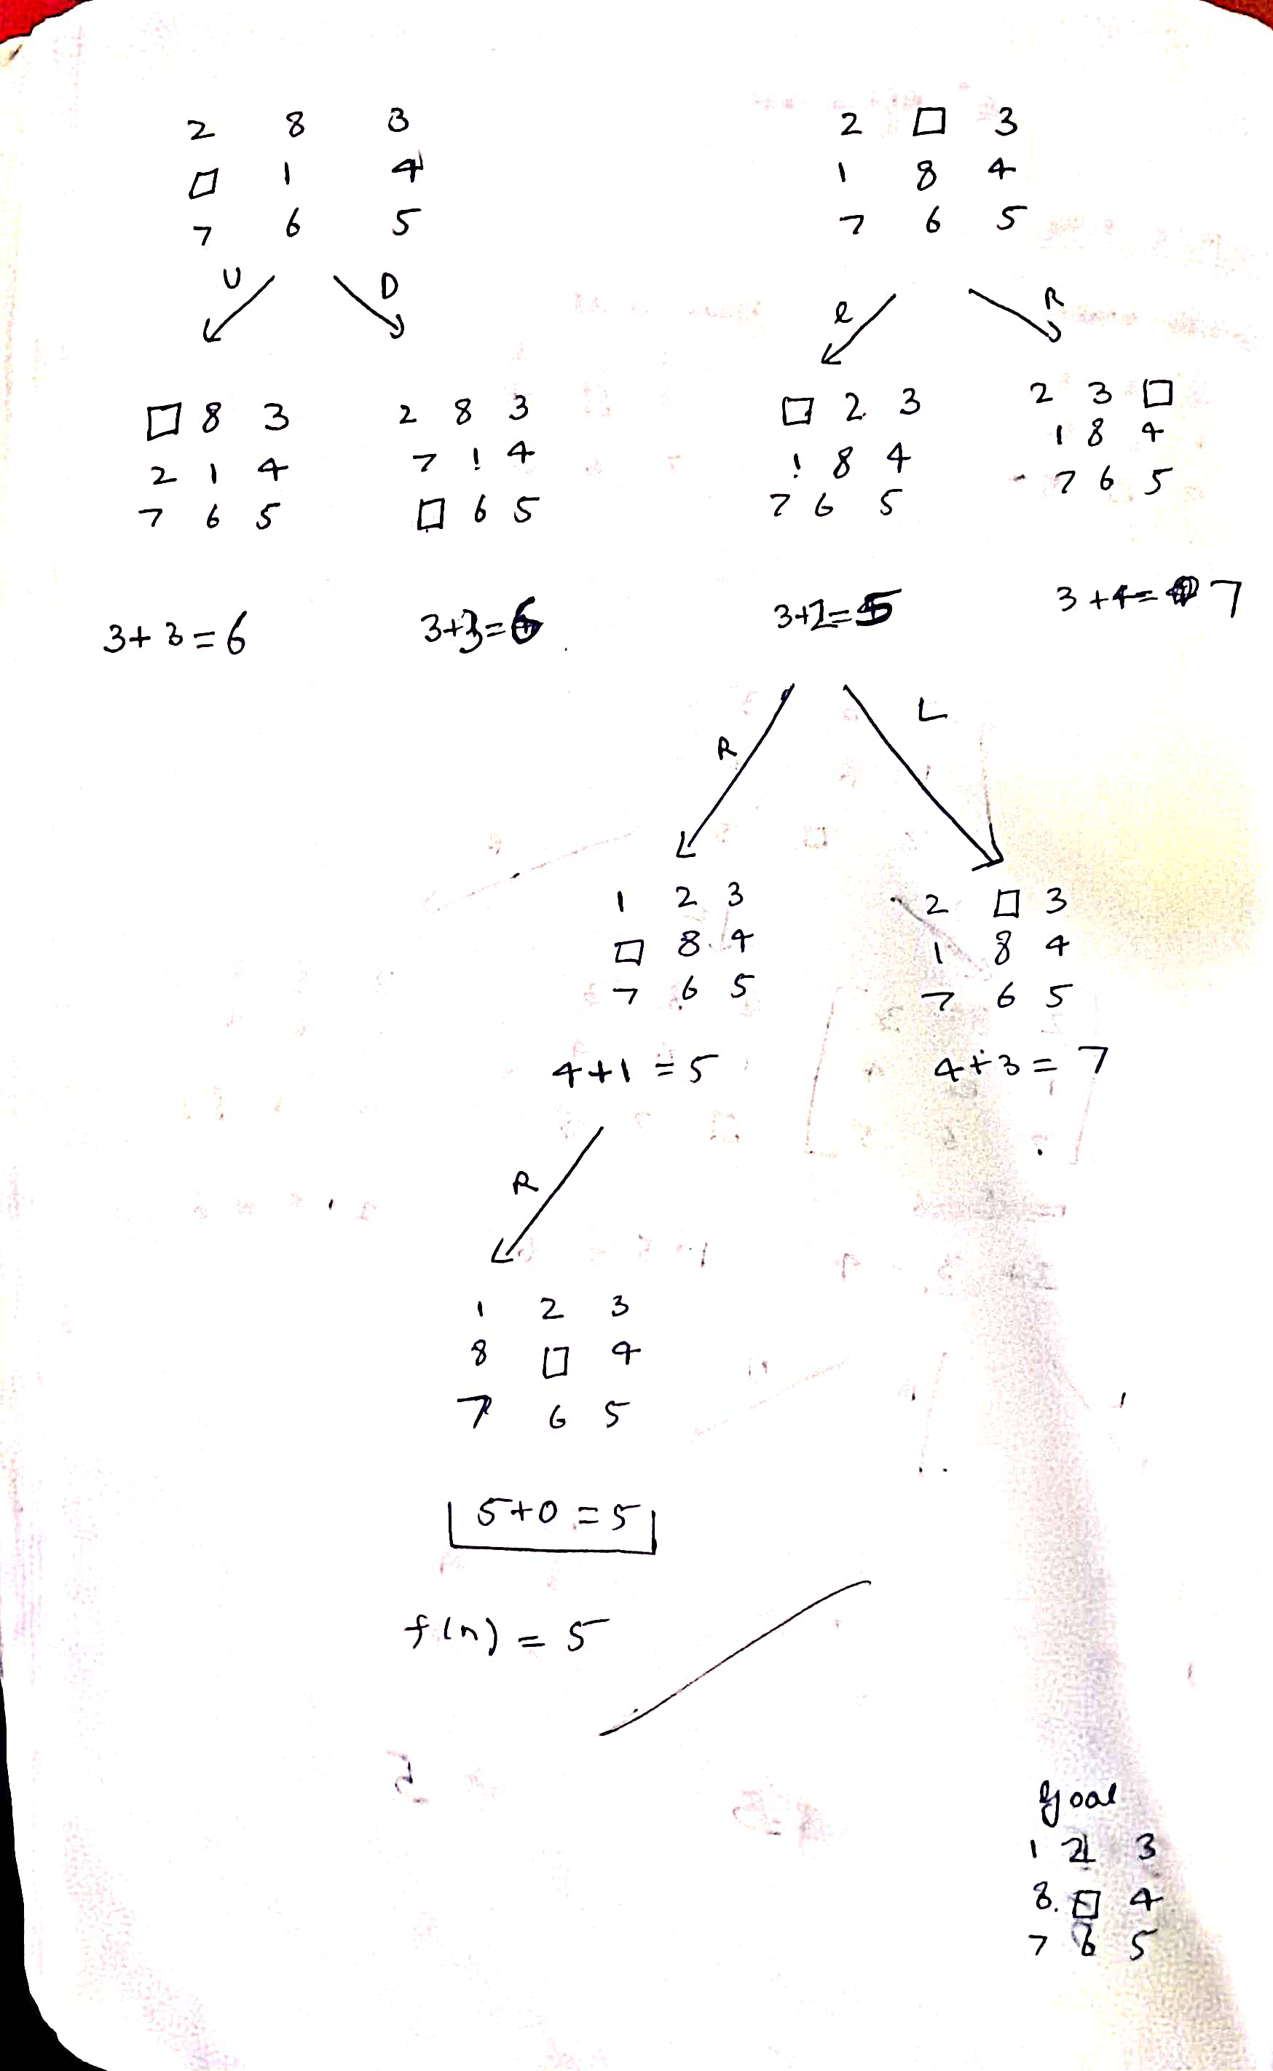

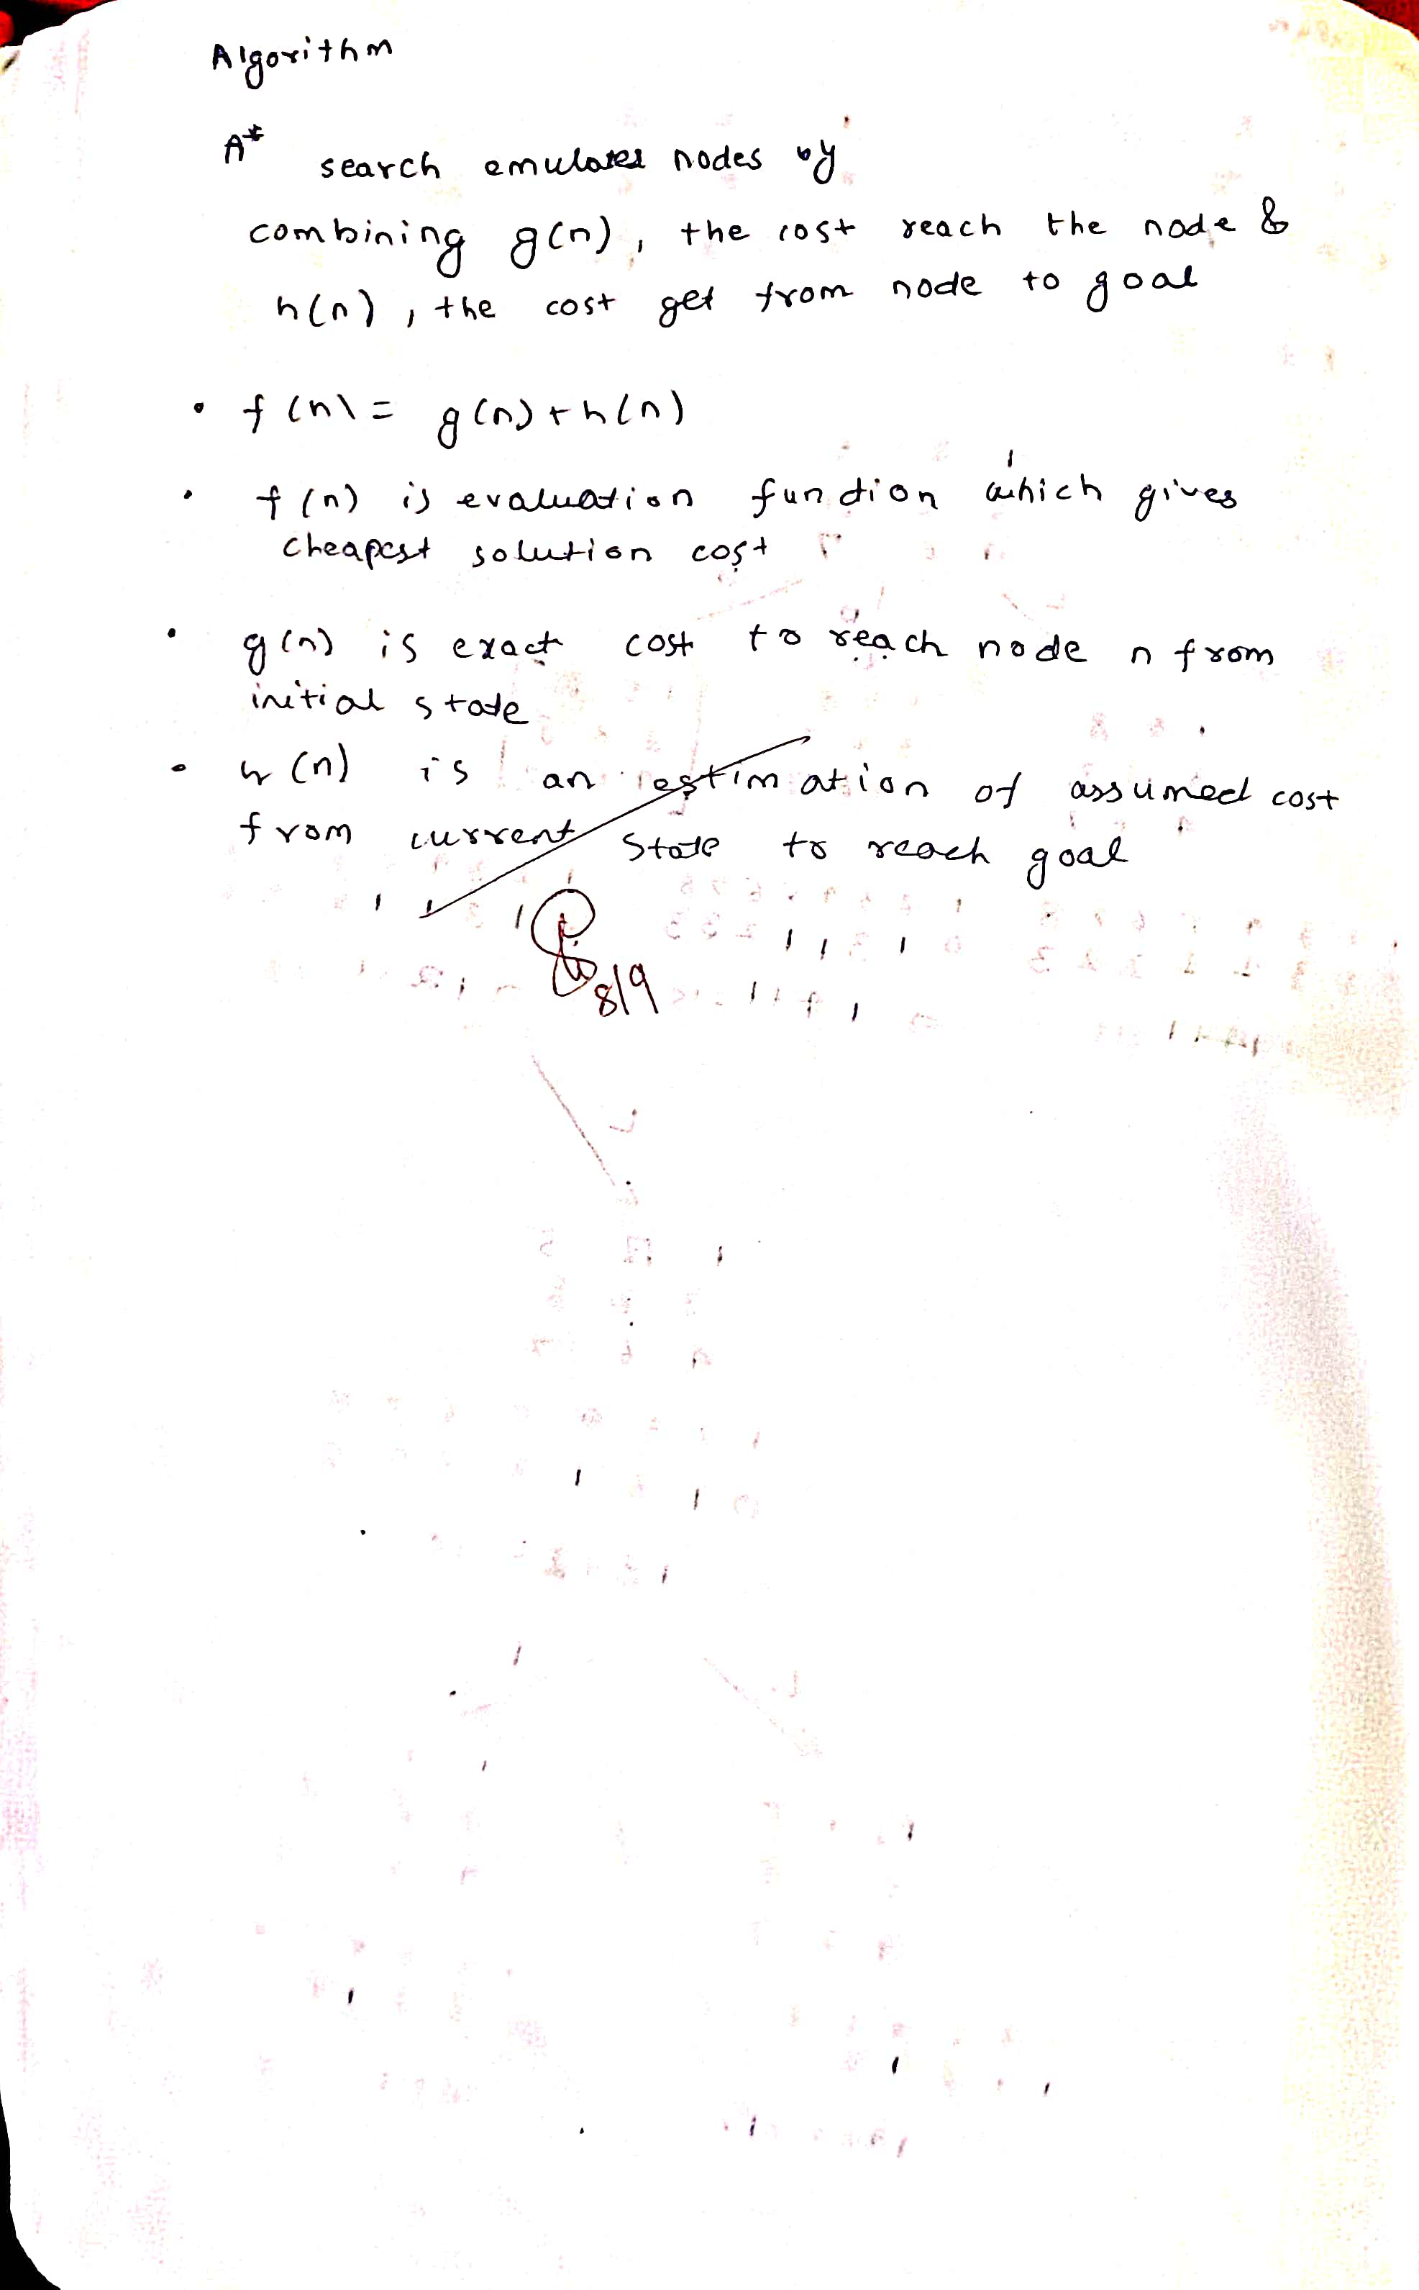

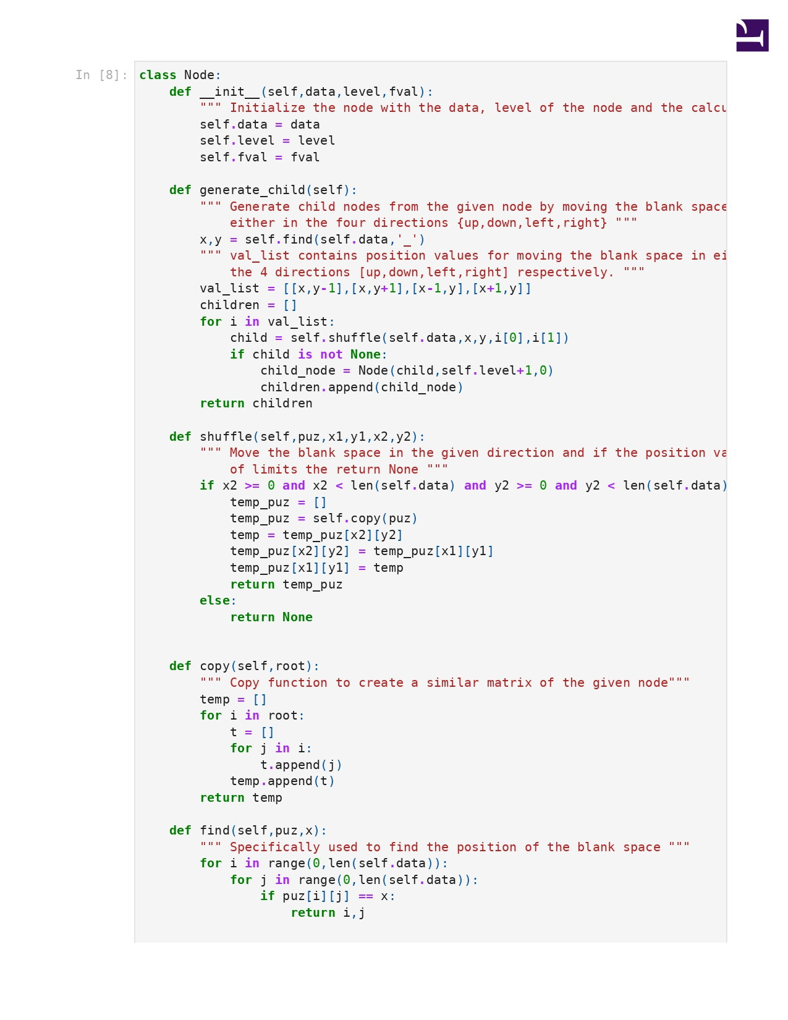

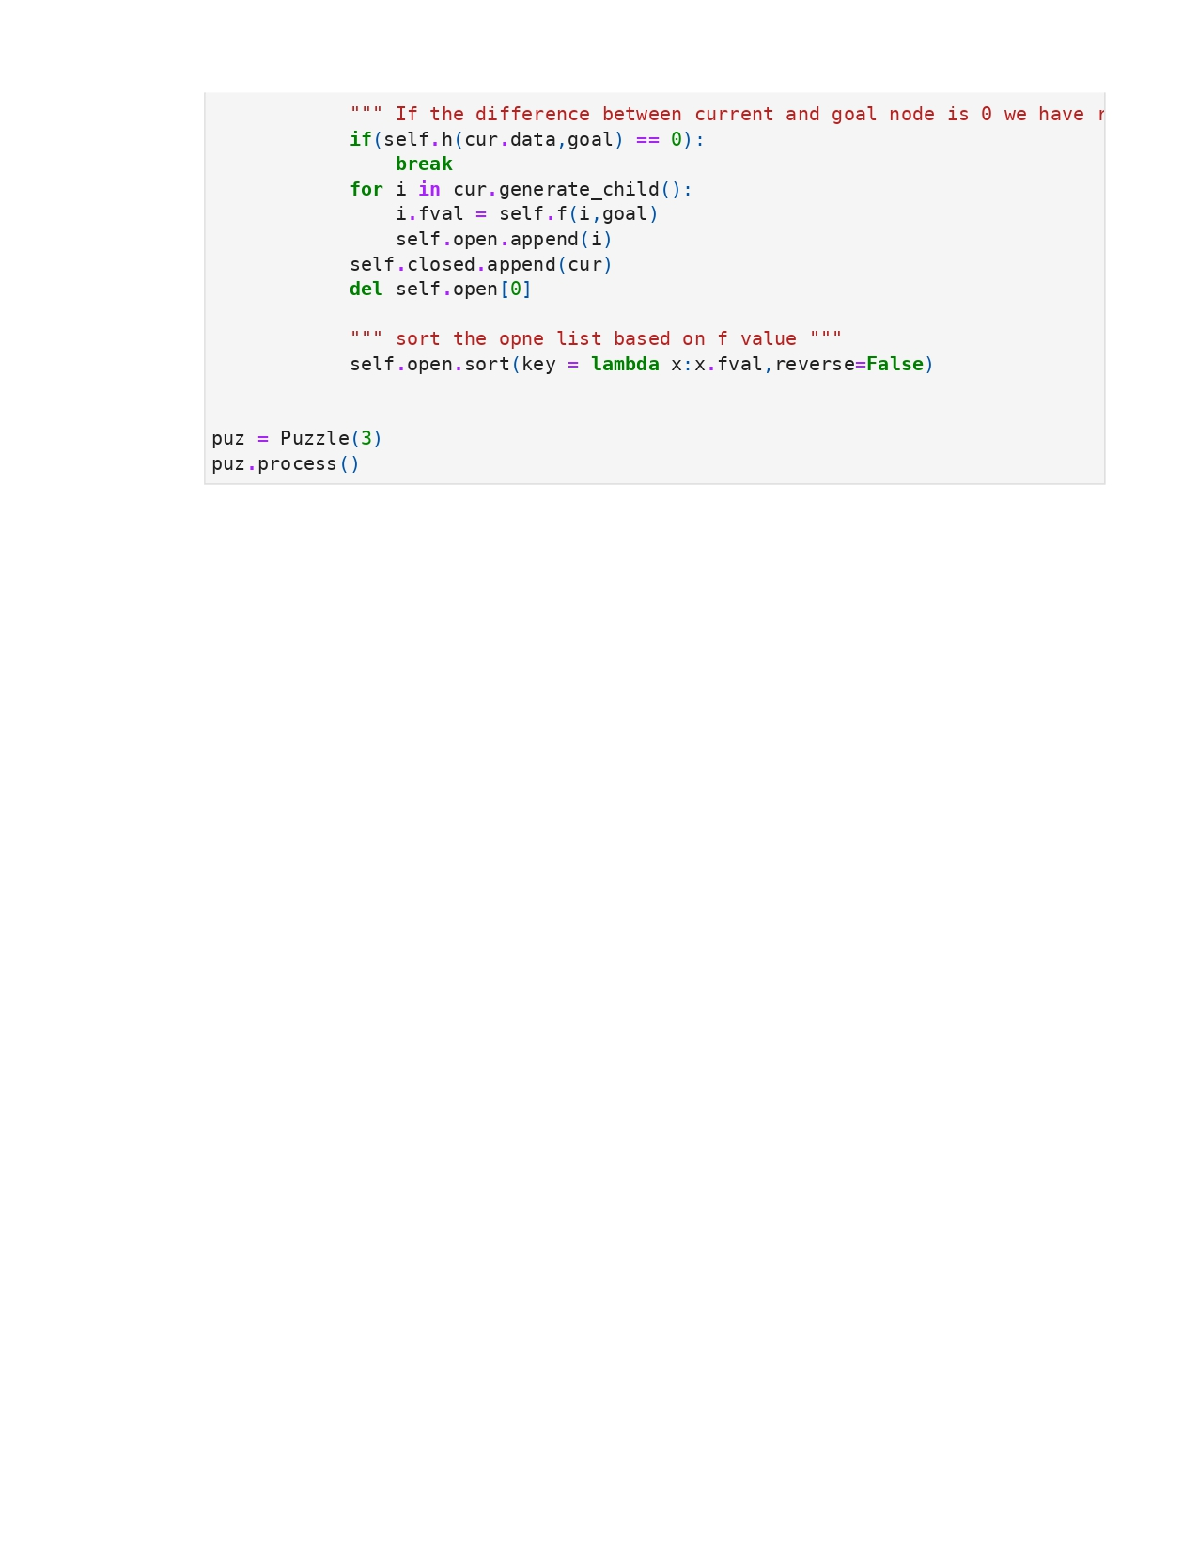

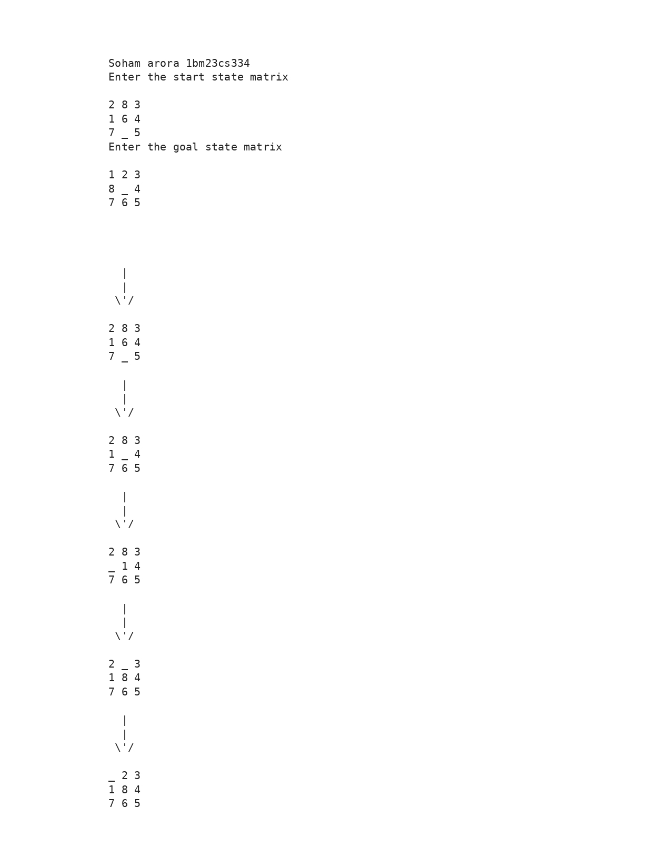

**Program 4**

Implement Hill Climbing search algorithm to solve N-Queens problem

Algorithm:

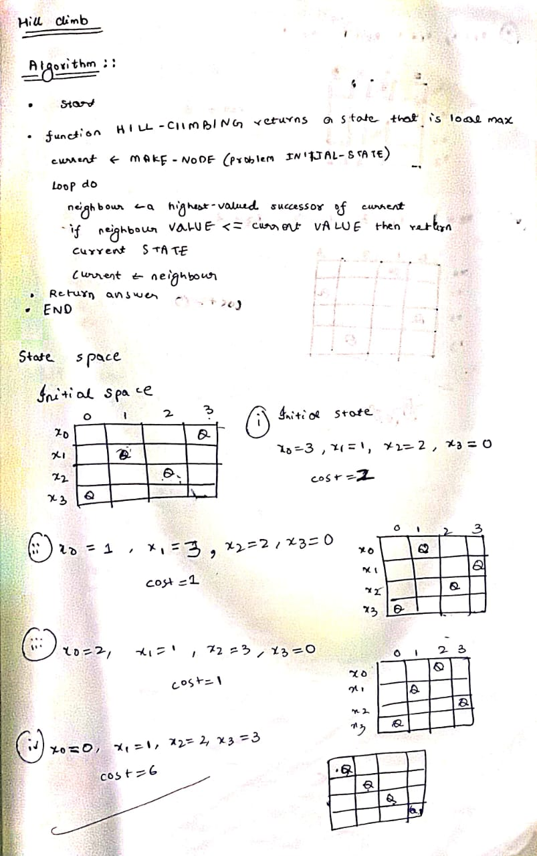

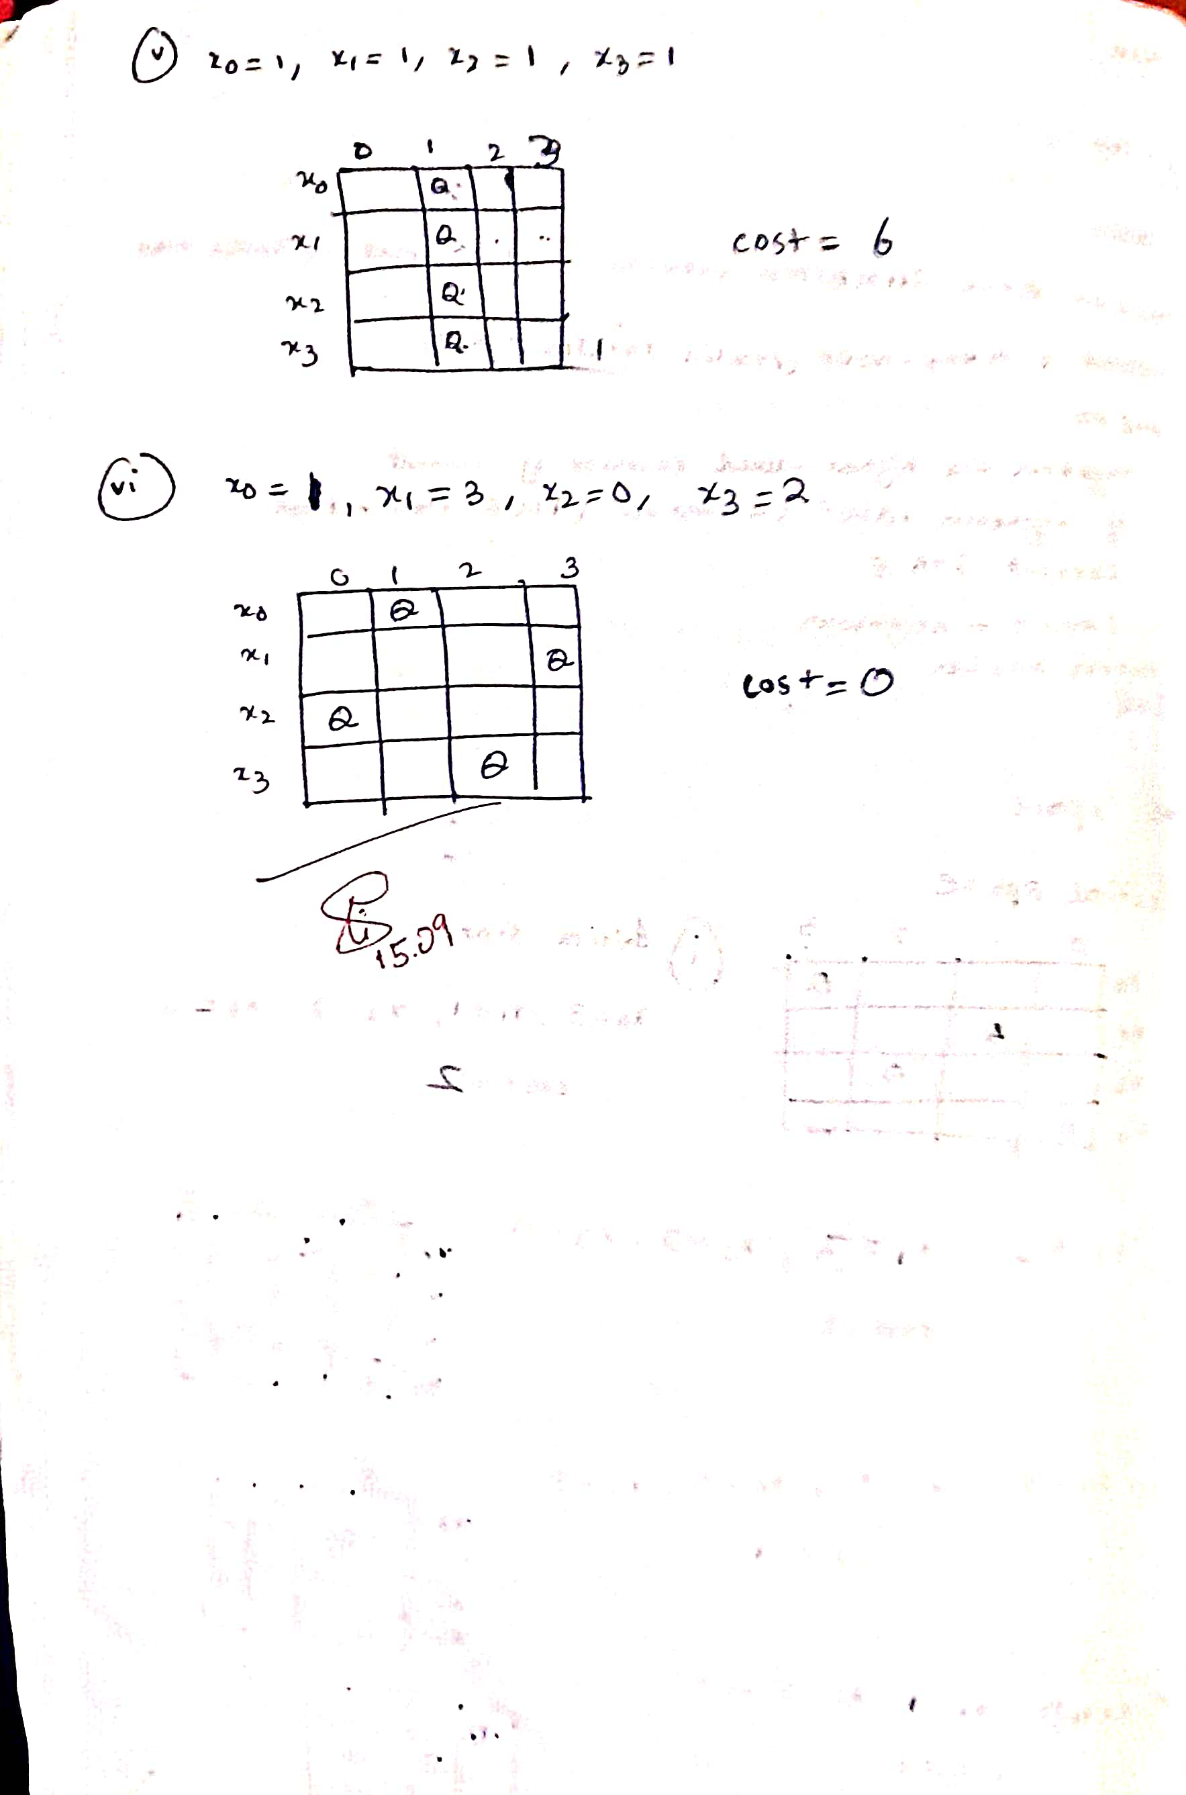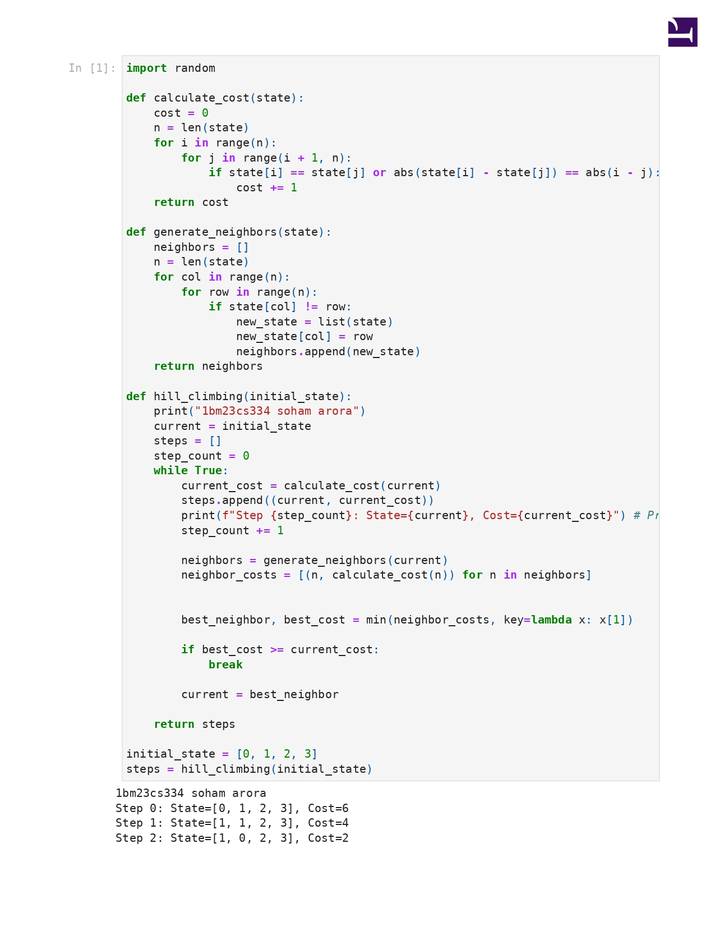

**Program 5**

Simulated Annealing to Solve 8-Queens problem

Algorithm:

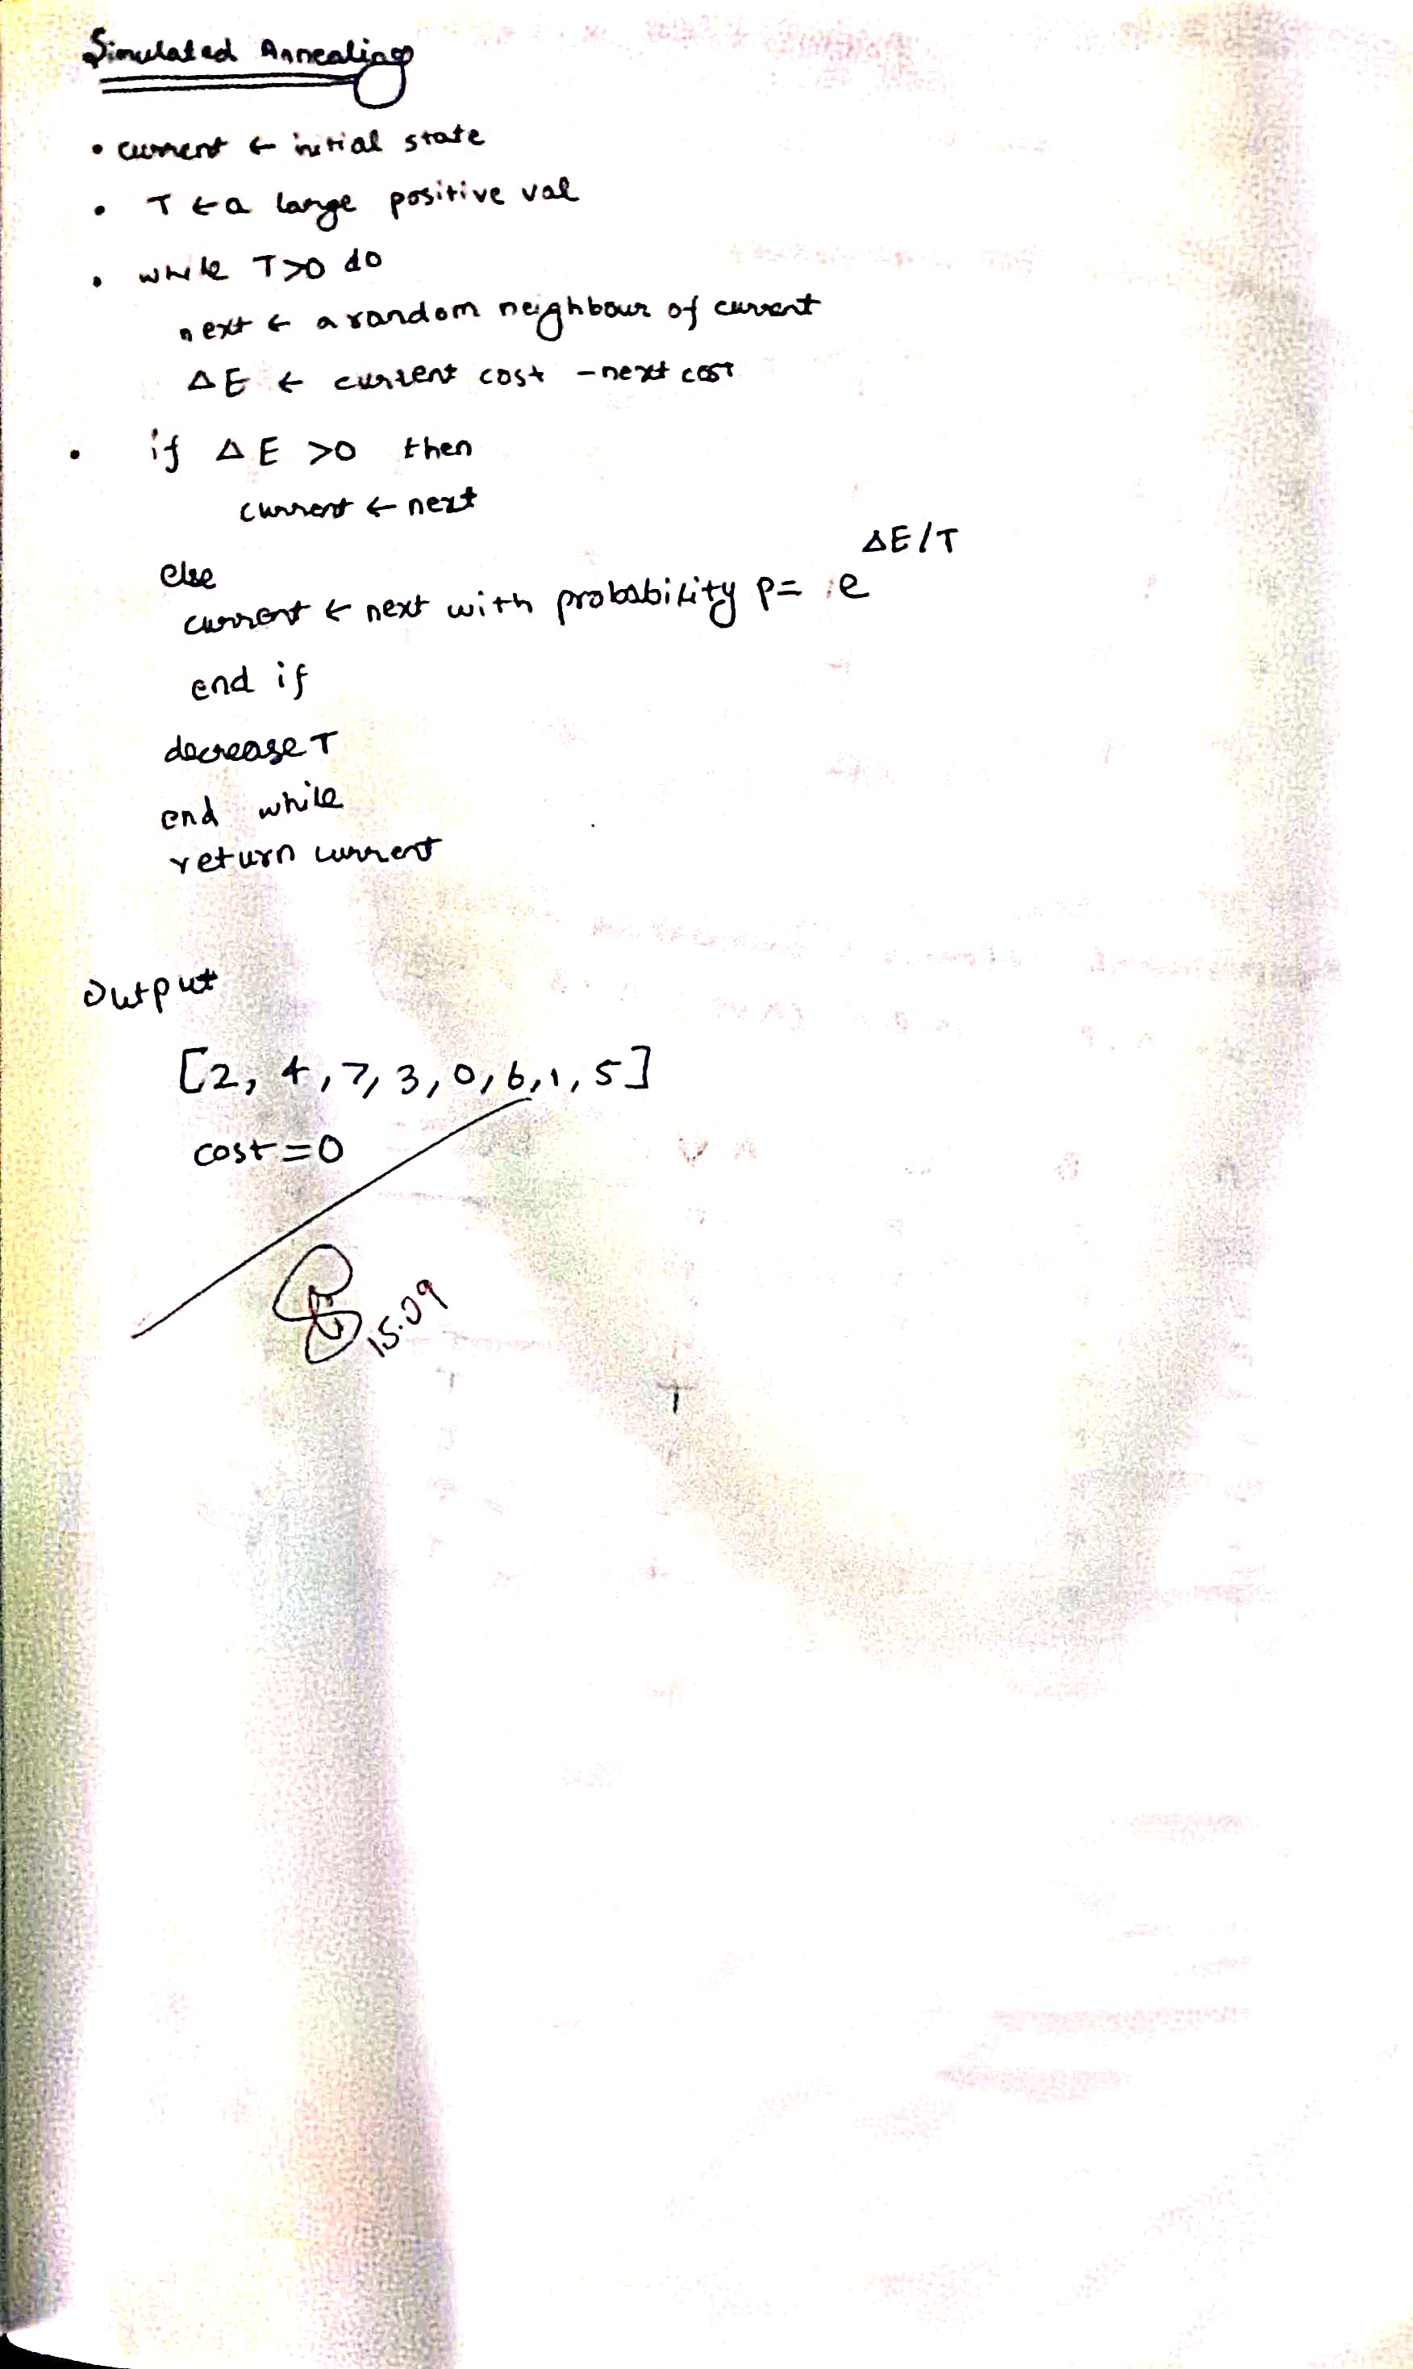

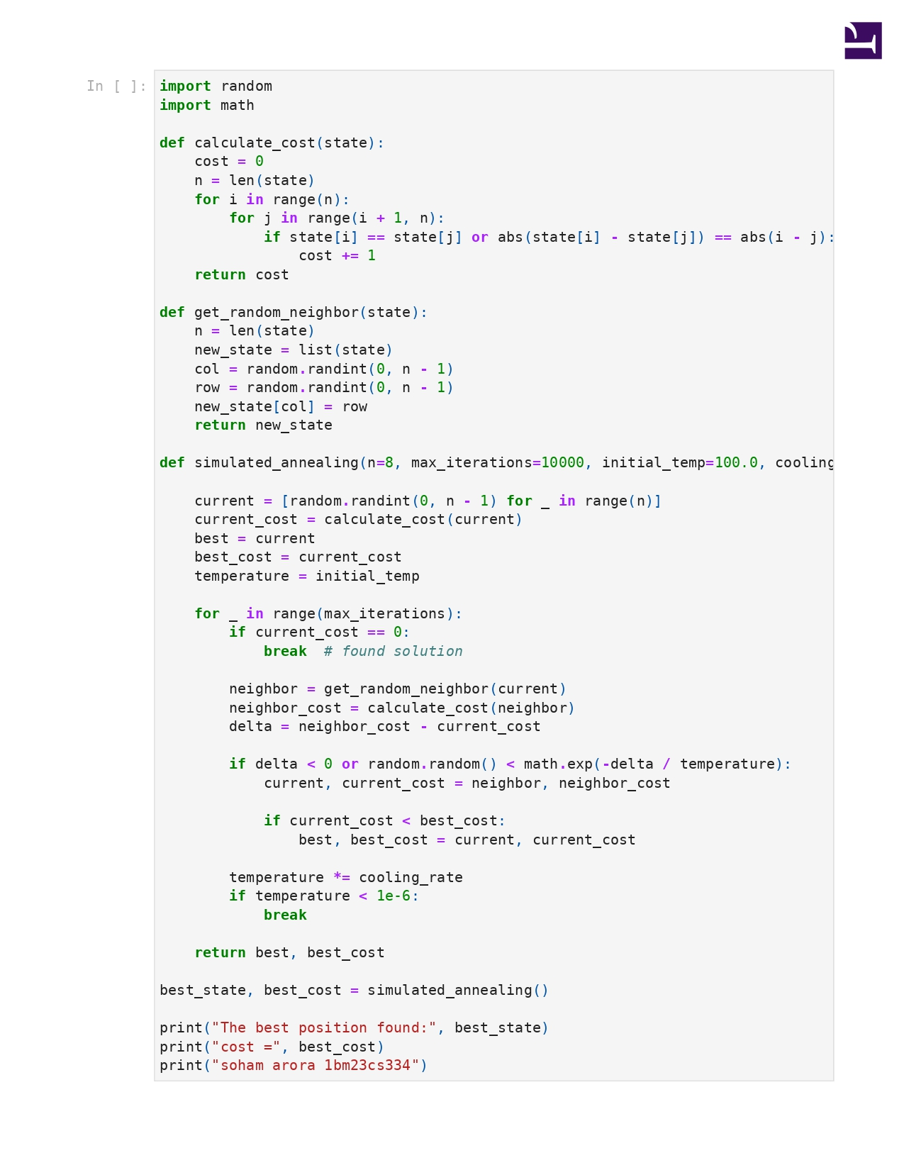



**Program 6**

Create a knowledge base using propositional logic and show that the given query entails the knowledge base or not.

Algorithm:

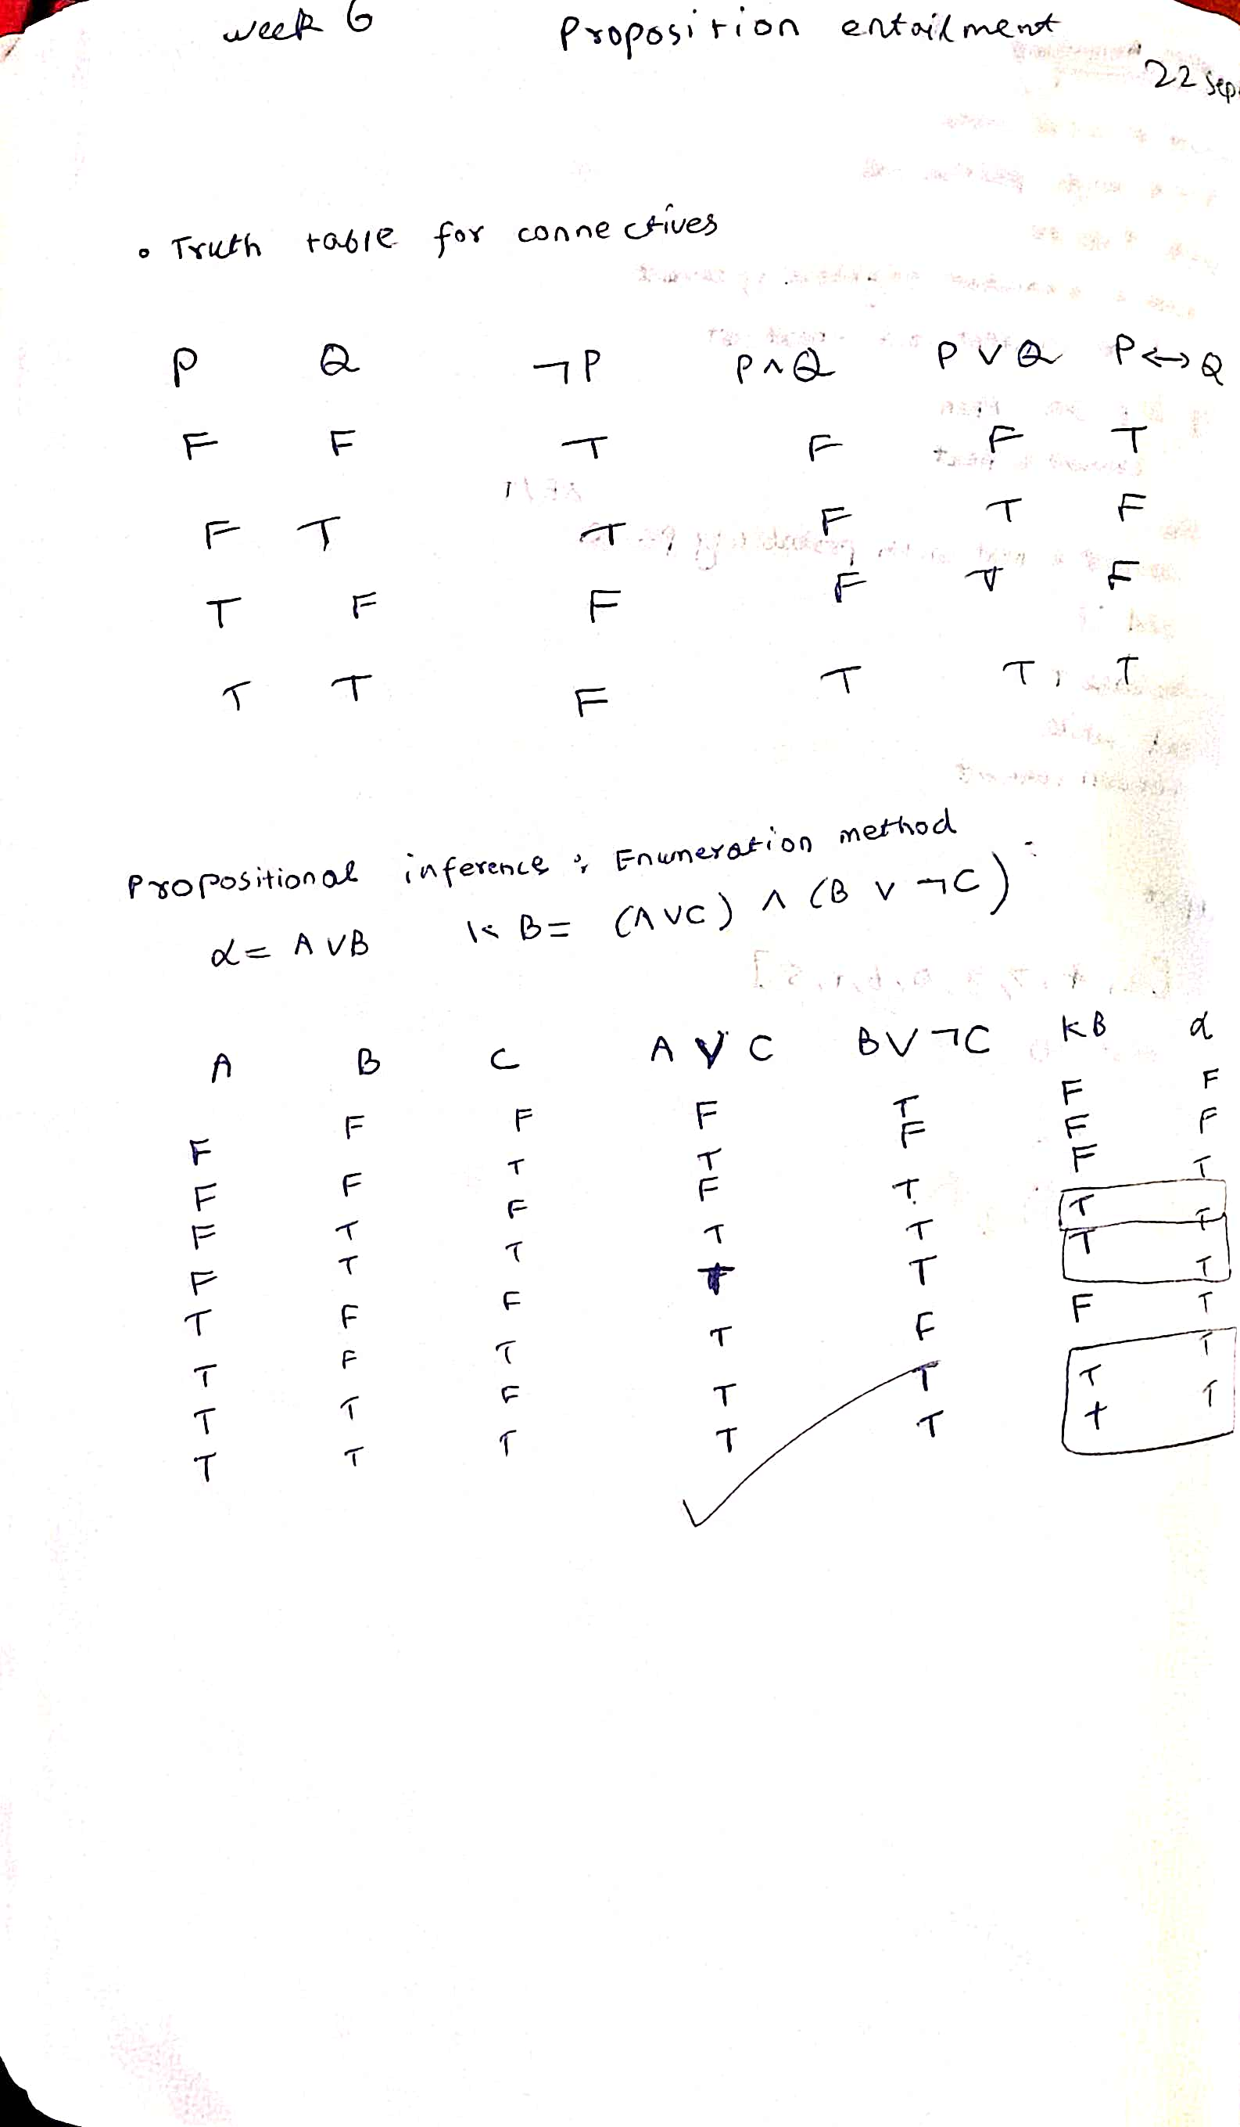

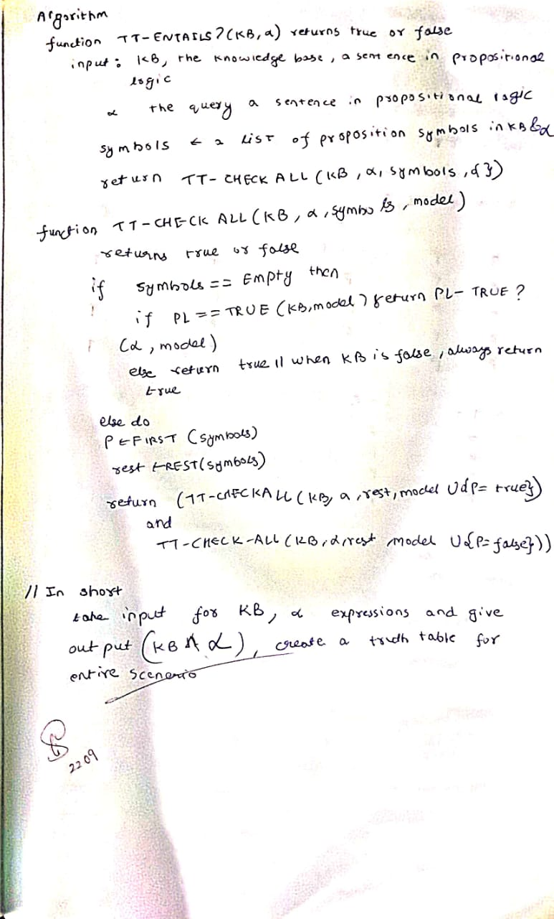

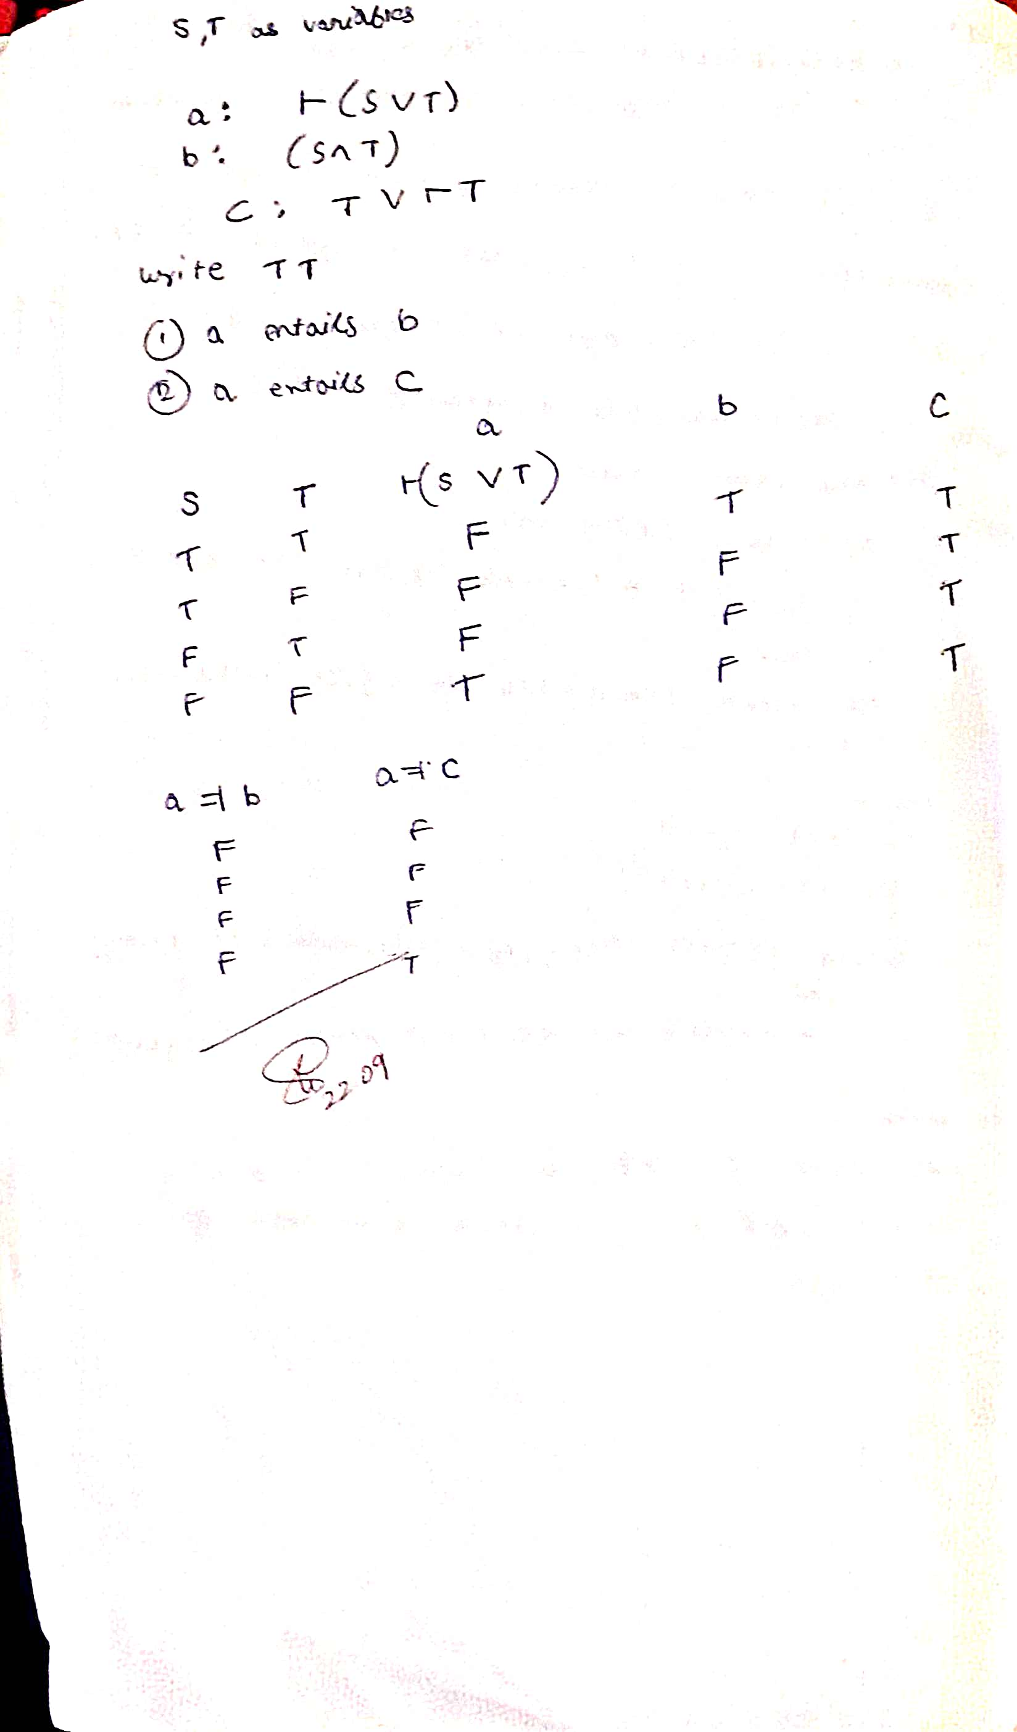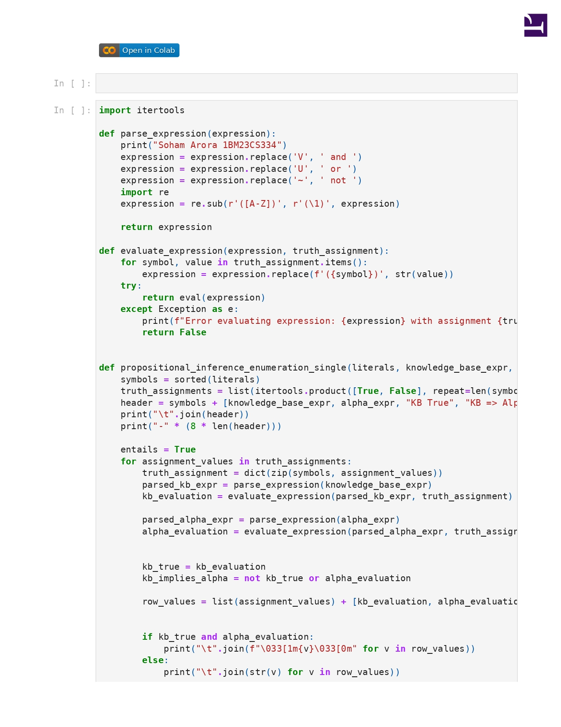

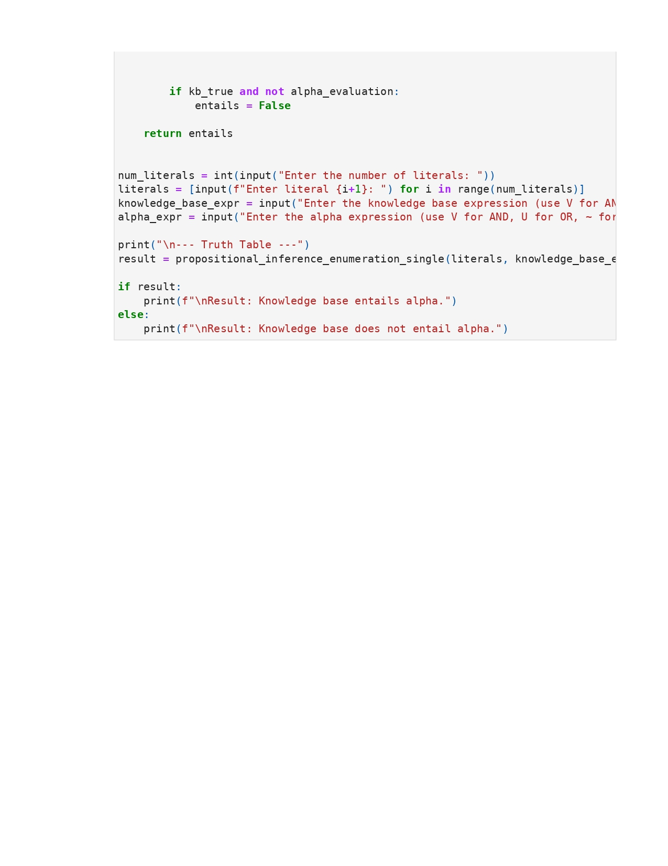

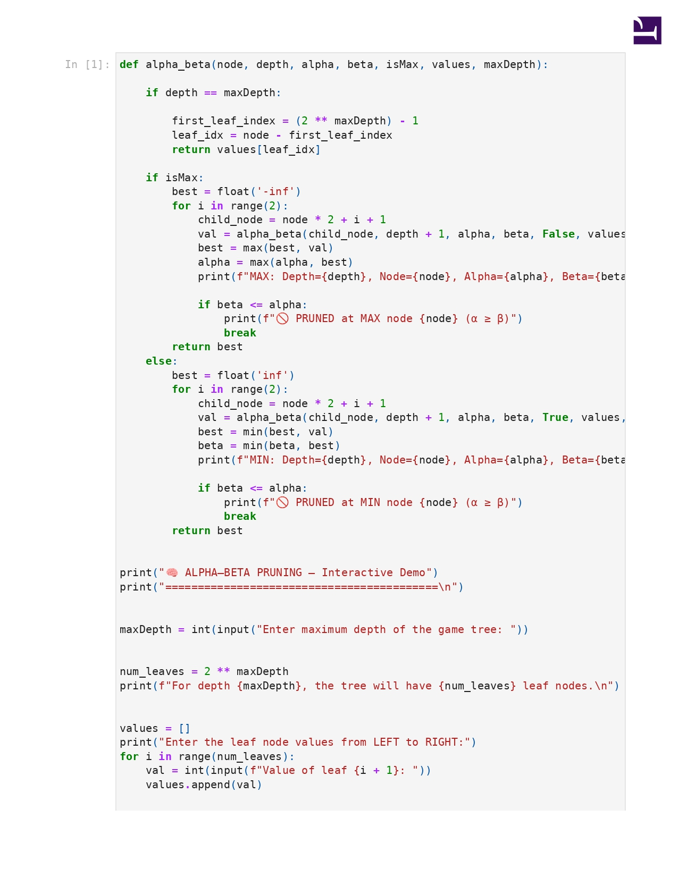

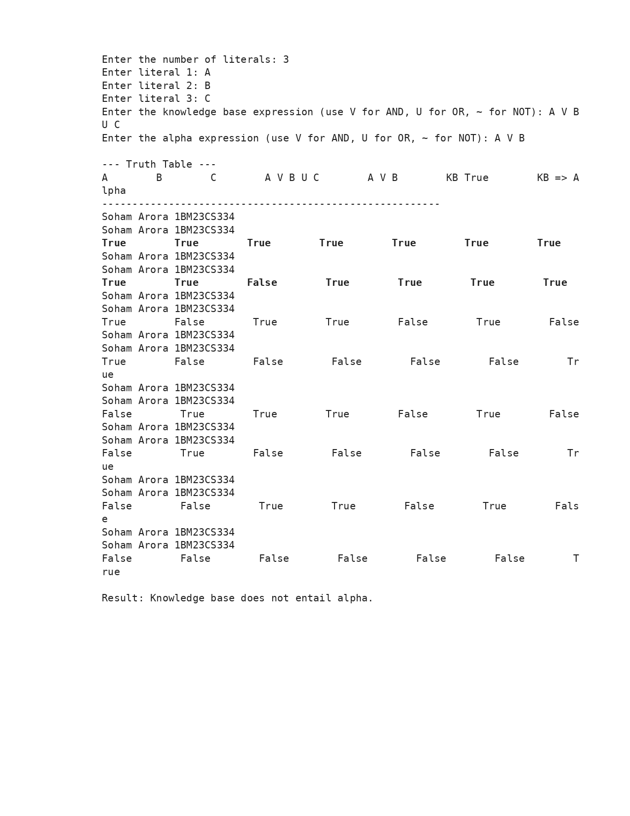

**Program 7**

Implement unification in first order logic

Algorithm:

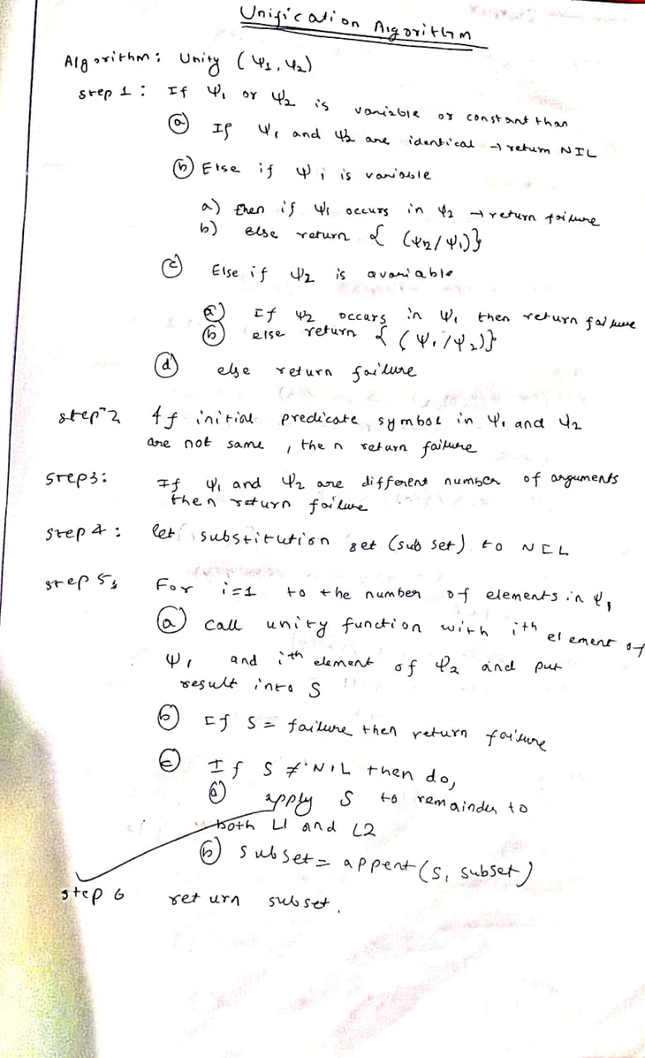

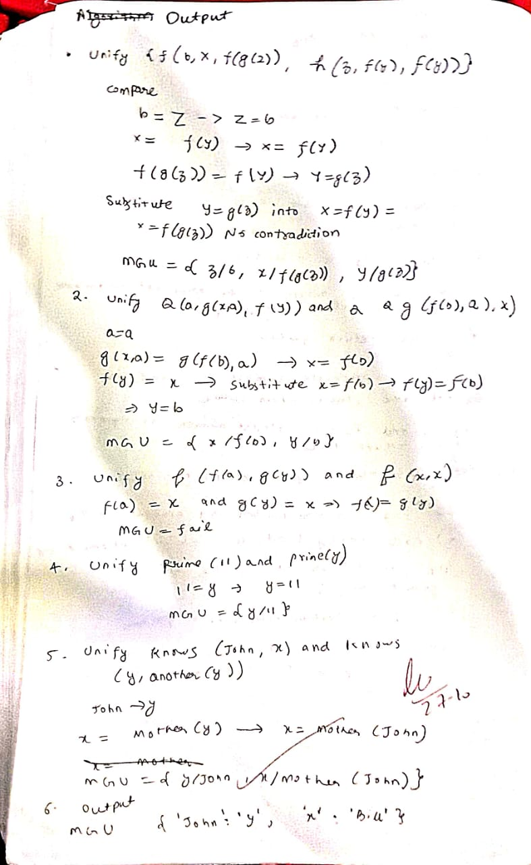

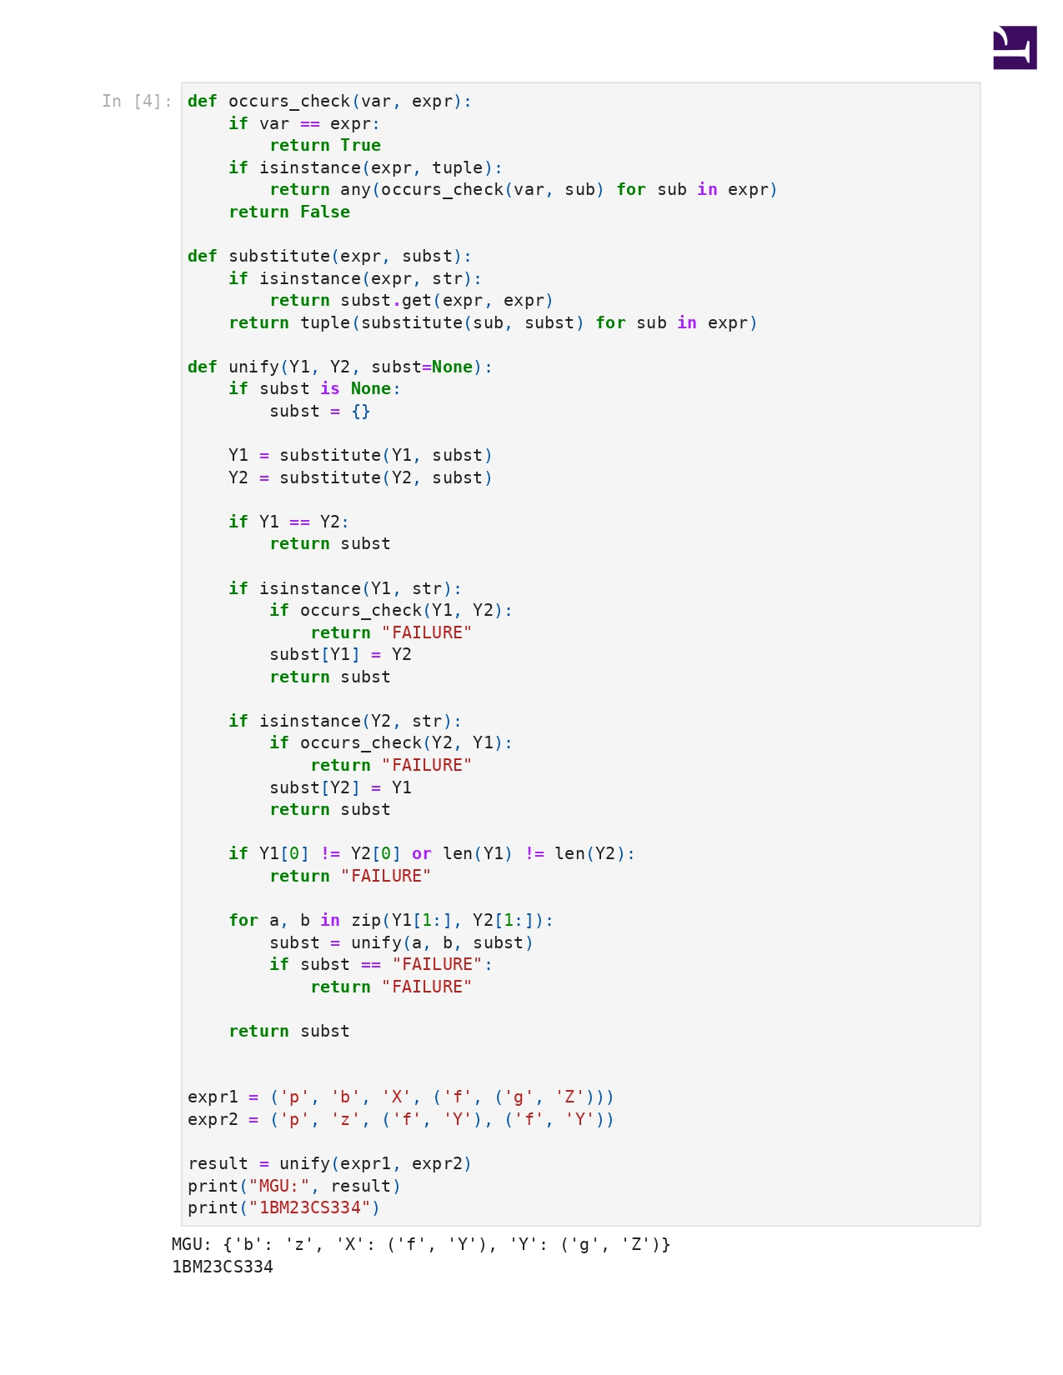

**Program 8**

Create a knowledge base consisting of first order logic statements and prove the given query using forward reasoning.

: 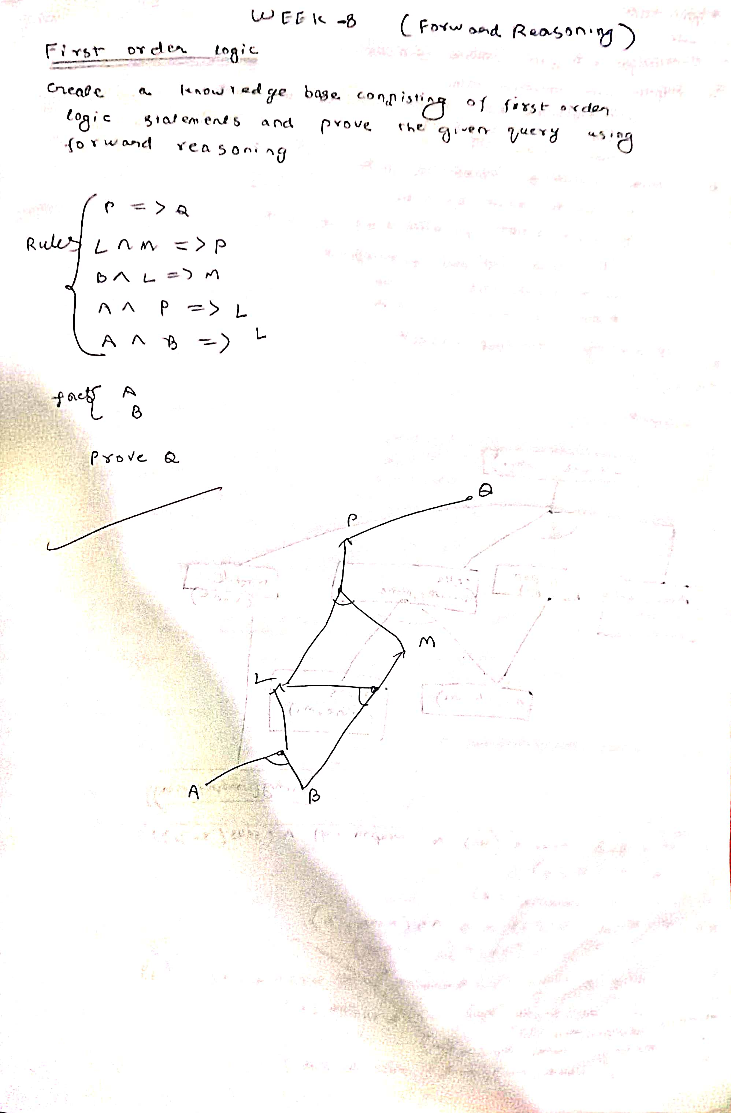

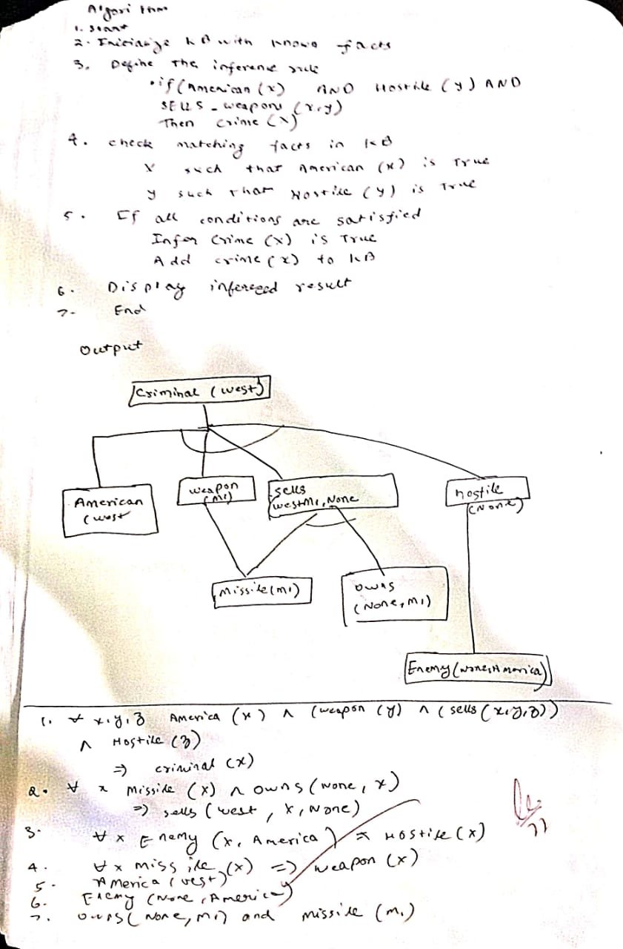

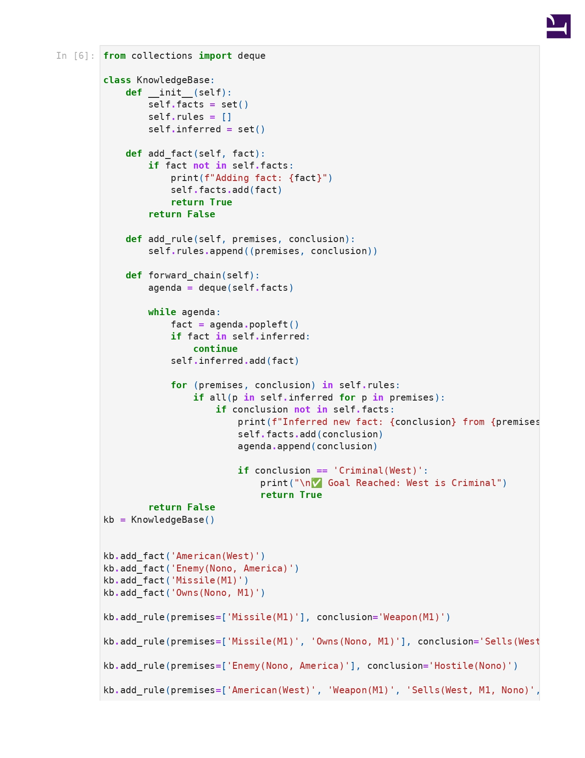

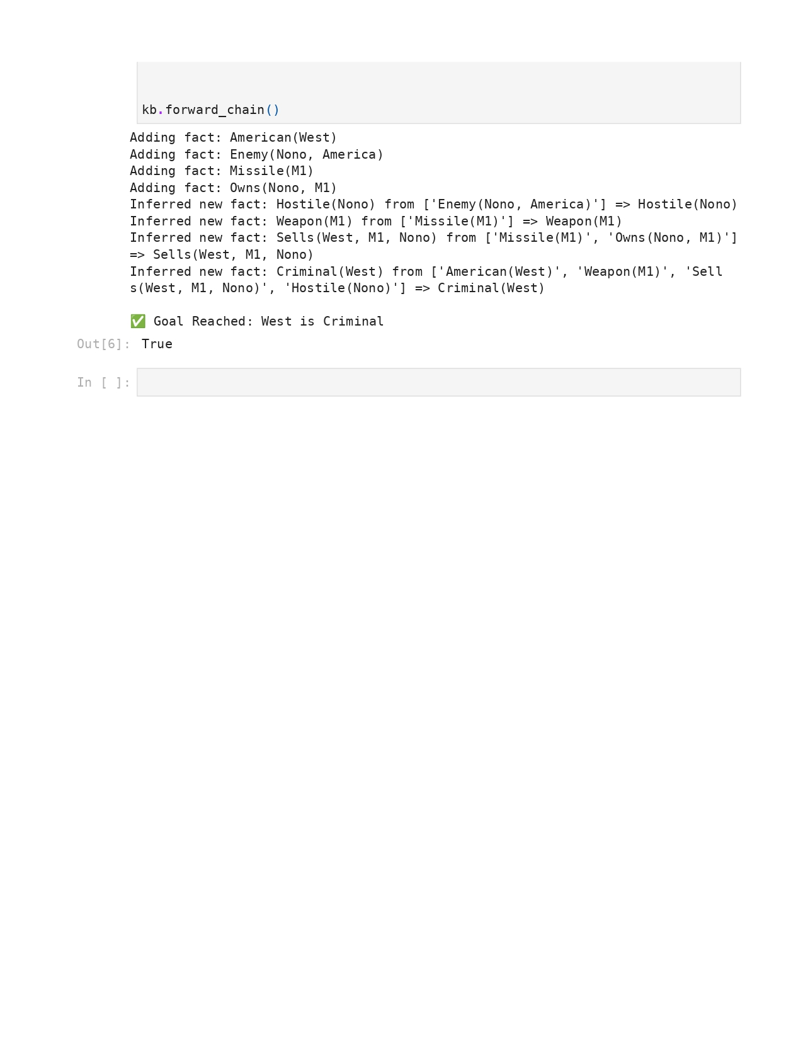

**Program 9**

Create a knowledge base consisting of first order logic statements and prove the given query using Resolution

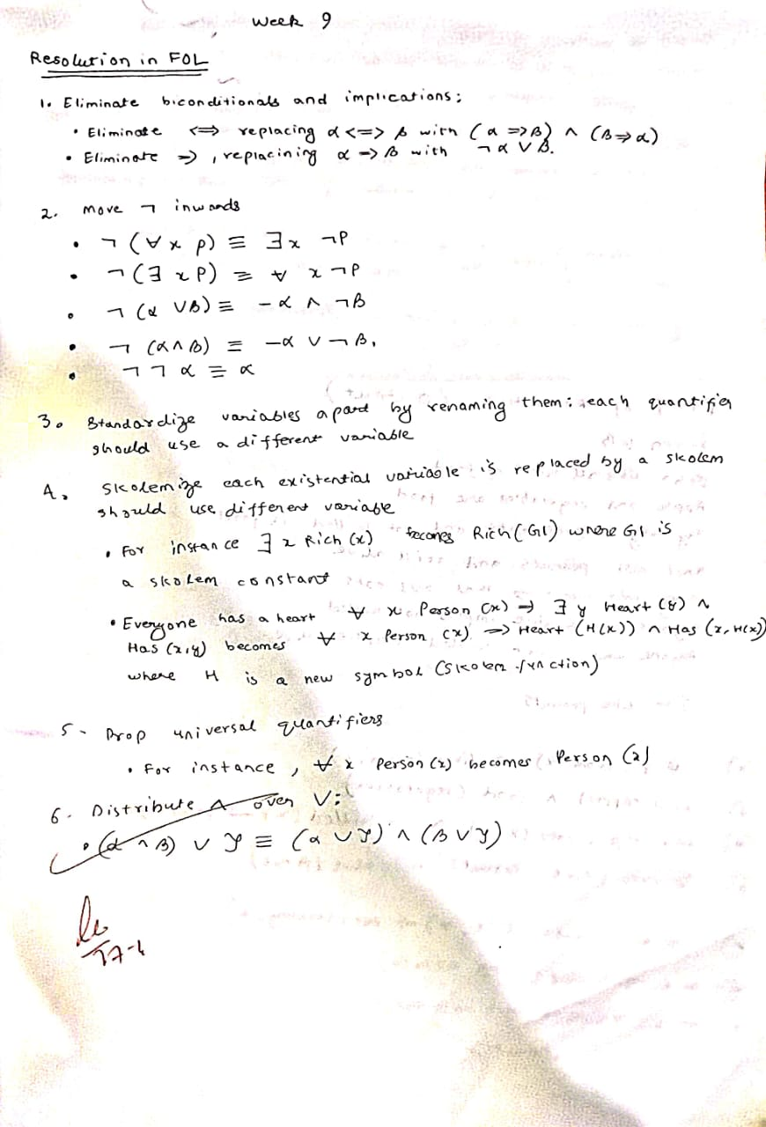

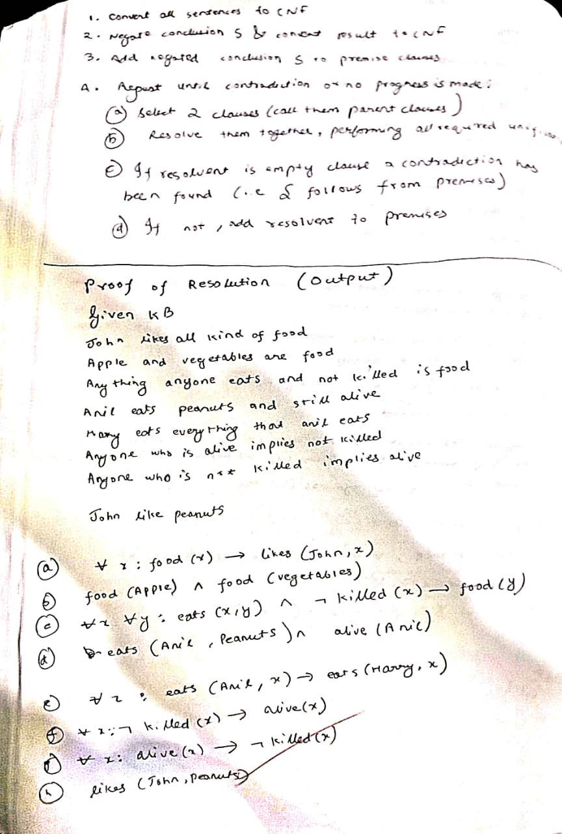

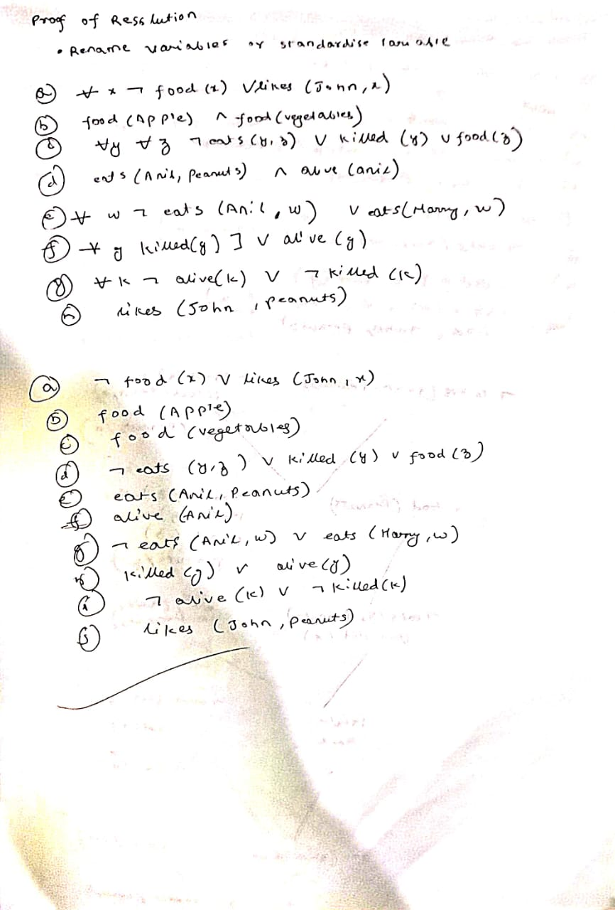

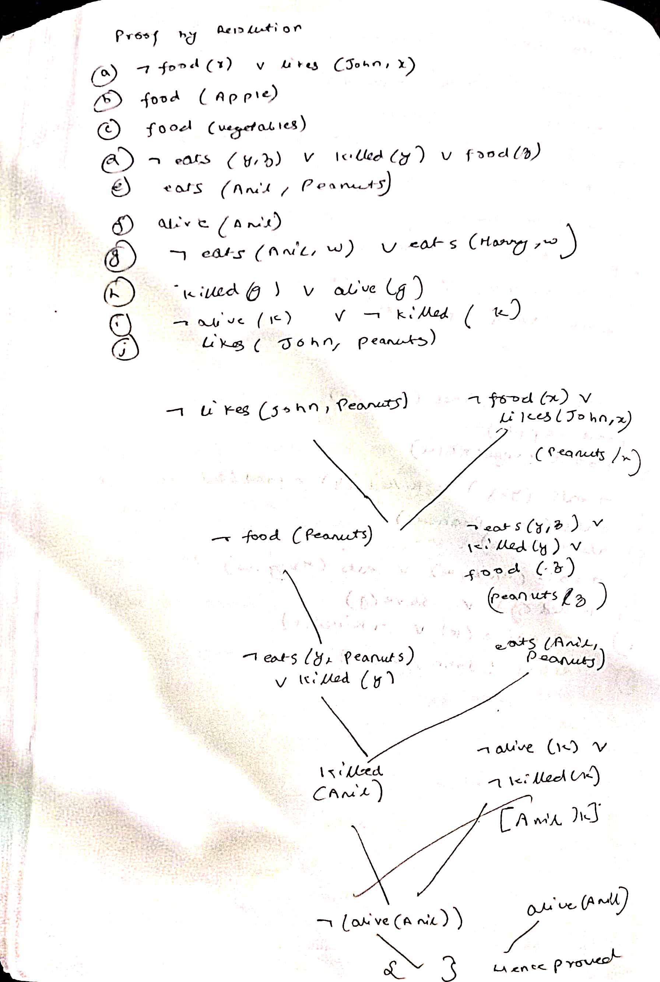

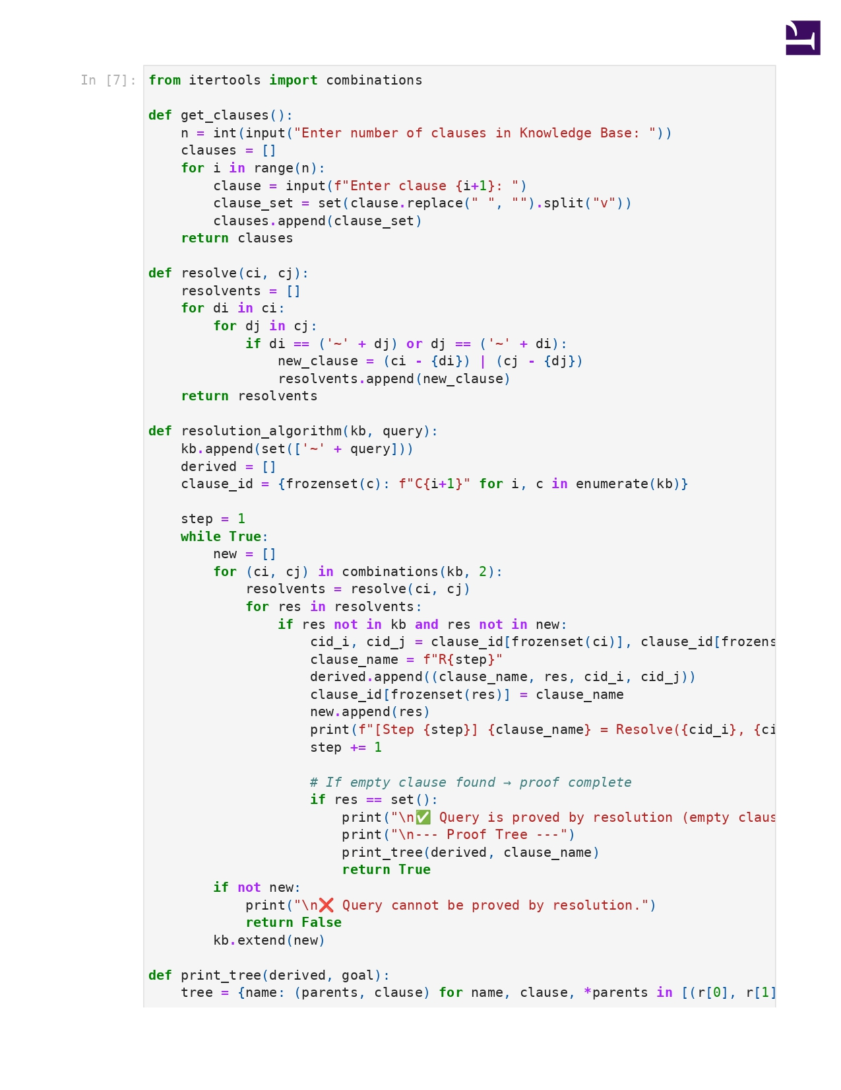

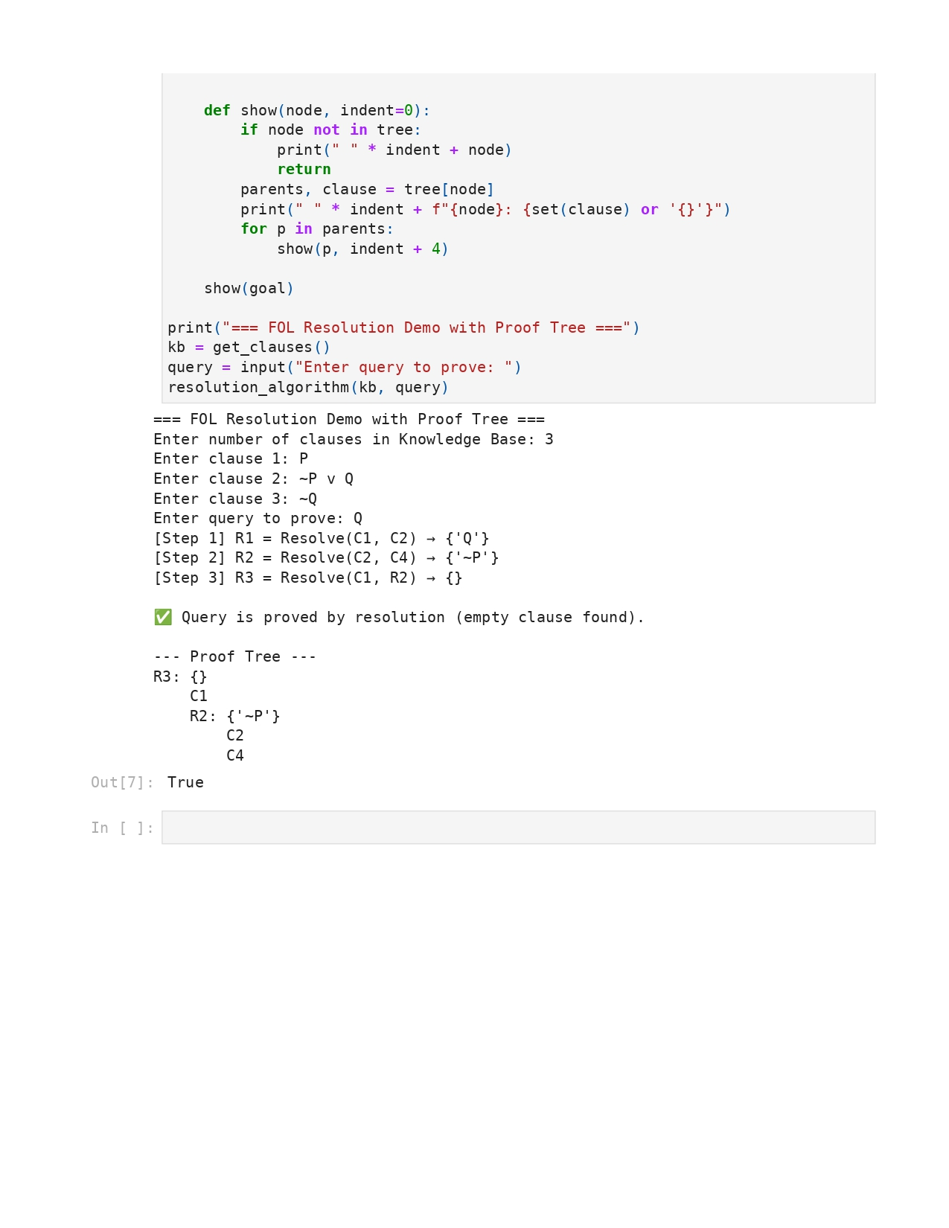

**Program 10**

Implement Alpha-Beta Pruning.

Algorithm:

